# FORM OF RETURN OF ELECTION RESULT

DIOCESE OF: St. Edmundsbury and Ipswich

ELECTION OF 1 PROCTOR IN CONVOCATION TO REPRESENT THE DIOCESE IN GENERAL SYNOD held on 18th May 2023 following the resignation of Revd Leslie Siu, which created a vacancy.

I, the undersigned, being the presiding officer for the election of proctors in Convocation for the diocese,

CERTIFY THAT the person whose names are listed below has been duly elected in the diocese.

|  |  |  |  |  |  |  |
| --- | --- | --- | --- | --- | --- | --- |
| Stage  at which elected | Surname (alphabetical order) | Full Christian Names | Title or preferred style | Address - including postcode | e-mail address | Year Of Birth |
| 1 | Gaze | Sally Ann | The Ven. | 13 Spring Park, Otley, Suffolk IP6 9NX | archdeacon.sally@cofesuffolk.org | 1969 |

Dated this 31 day of May 2023

Signed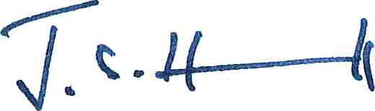 James Hall - Presiding Officer

The election was conducted using the votes cast in 2021.

PLEASE ATTACH FULL RESULT SHEET

A copy of this return of election result and the result sheet (showing full voting figures) should be sent to every candidate in the election and to the Clerk to the General Synod (at Church House, Great Smith Street, London SW1P 3AZ, clerk@churchofengland.org).