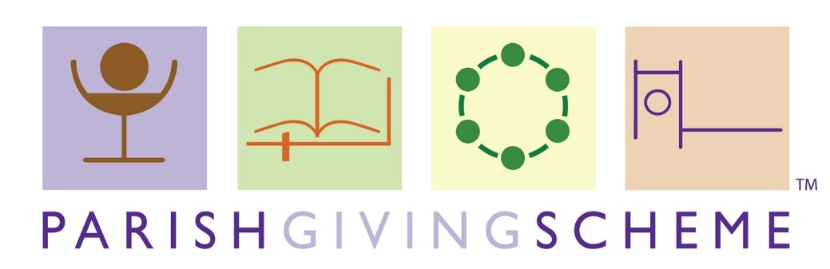
Short Guide and FAQs

A simple and efficient way to give directly to your parish

The Parish Giving Scheme (PGS) is a simple and secure way for churches to receive regular donations. It is an established service for managing Direct Debit donations, designed to support churches to fund their mission and ministry from those within the church or in the wider community. The service is freely available to all parishes and donors, and registering your parish is quick and simple.

Over 180 parishes in our Diocese are already benefitting from the scheme, with more than 1,400 donors giving regularly through the PGS, collectively giving £100k each month to their churches. Across 2020, over £1m was given through the scheme – this was gratefully received by parishes, especially during national lockdown and subsequent church closures.

Why the PGS?

- The scheme helps to build financial resilience by making it easy for a donor to give their gift irrespective of whether they are physically in the church.
- By processing regular donations and Gift Aid on a church’s behalf, PGS eases the admin burden and improves cashflow.
- Donors can choose to increase their gift annually in line with inflation. A £10 weekly gift setup in 2010 rising with inflation would be worth £13 in 2020. This represents an additional £140 per year per donor.
- Parishes on the scheme are more likely to see an increase in total planned giving (donations) and gift per donor. Giving per donor in PGS parishes is almost 25% higher compared to parishes not adopting the scheme.
- Parish treasurers can view monthly statements securely online and can use the bespoke resources provided by the PGS to promote the scheme on their A Church Near You page, webpage and in parish newsletters.

For information about joining the PGS and to find out more:

Julie Podd, Parish Finance & Resources Advisor julie.podd@cofesuffolk.org | 01473 298555
Lee Jukes, Parish Finance & Resources Manager lee.jukes@cofesuffolk.org | 01473 298551
Gary Peverley, Finance Director gary.peverley@cofesuffolk.org | 01473 298575

Frequently Asked Questions (FAQs)

Who operates the Parish Giving Scheme?

The PGS is a church-run not-for-profit company and is a registered charity (1156606).
You can find out more about the Parish Giving Scheme by visiting their website parishgiving.org.uk

Why should my parish join the PGS?

Those who wish to give to your church should have a variety of platforms available to choose from, ensuring that it is easy as possible for them to donate. These should be outwardly visible and easy to access. The PGS is a great platform for planned givers and those community supporters who are happy to give regularly to your church. The regular gifts help with cashflow and Gift Aid is automatically reclaimed and remitted to your parish bank account.

How does my parish join the PGS?
- Agree to join at your next PCC meeting.
- Simple registration form (available on website or by email) is completed and returned to pgs@cofesuffolk.org.
- It usually only takes a few days for PGS to confirm registration.
Does it cost our parish anything?
- PGS is free at point of use.
- The Diocese pays to be part of the scheme.
When does our parish receive the donation?
- The donation is taken from donors’ accounts on the 1st of each month and remitted to church bank accounts on the 10th of each month.
- The PGS automatically reclaims any Gift Aid from HMRC and remits it to the church account as soon as it is received.
Does everyone in the parish have to give by PGS?
No, this is another tax efficient way of giving that can reduce the workload for treasurers, but all gifts are gratefully received in whatever form. Parishes should consider several different platforms to suit those who wish to support their parish, from within and outside of the congregation
How can we see what has been given?
Statement Receivers (usually the treasurer) have access to monthly statements through the PGS website. www.parishgiving.org.uk

Why is inflation so important?

Static giving is a huge problem for local churches and inflation proofing donations would help. There is an option to increase the donation annually and the example below shows how this can make a difference:
• 2016, weekly gift of £20.00 + £5.00 Gift Aid = £25.00
• If gift increases in line with Retail Price Index (3.2%)
• 2026, weekly gift of £27.00 + £6.75 Gift Aid = £33.75 (an extra £455.00 per year)
What resources are available to parishes?
- Statement Receivers have access to bespoke PGS resources (promoting and using the PGS) on their section of the PGS website.
- Personalised PDF of the Gift Form
- Template letters to potential donors
- Personalised telephone notice template
- Advice from the Stewardship Team on where and how to promote the scheme.
- Banners (2) are available to borrow: ‘Make a difference, support our church’ or ‘Build a confident future for your church’ by emailing pgs@cofesuffolk.org stating which banner you would like to borrow and the dates.
Why do we need a Statement Receiver and Project Leader?

The Statement Receiver (often the treasurer) will have access to a monthly online statement showing who is donating and all the financial/gift aid details. The Project Leader usually drives the rolling out of the scheme in the parish.

Why does the gift have to be made on the 1st of the month?
To be cost effective and more efficient the PGS had to choose one date.
Donation Journey
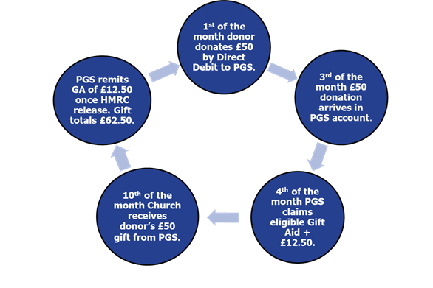

How should parishes promote the PGS?
- Promote on your A Church Near You page or website including PGS online link, how to join by telephone, and PDF of Gift Form.
- Use the PGS QR code on posters, pew sheets and in letters/parish newsletters.
- Run a stewardship programme/giving day highlighting ways to give.
What happens at the Offertory?
Reusable PGS tokens (available from pgs@cofesuffolk.org) can be used by donors on the plate.
How does joining the PGS impact on eligibility to claim under the Gift Aid Small Donations Scheme (GASDS).
- To claim maximum gift aid via GASDS a church needs to have received gift aided donations in the relevant tax year of £800 or more. Gift Aid donations made through the PGS do not count towards the latter.
- It is important to retain some non-PGS Gift Aid giving (envelopes, standing orders) proportional to the GASDS you are seeking to claim on. For example, if you typically claim on £4,000 of GASDS eligible donations you will need to ensure that at least £400 of non-PGS gift aid is claimed in your parish.
- This is not usually a problem as not everyone will want to transfer to the PGS but something to be aware of.
How do donors give through the PGS?
Donations can be monthly, quarterly, or yearly.
3 easy ways to give:
- Online (on the PGS website)
- By Phone (Tel: 0333 002 1271)
- By Post* (use the printable PDF)
*This replaces the paper Gift Form dated 2017, which is out of date and should not be used.
Do donors have to ‘opt’ into the inflationary increase?

No, it is a tick box on the form (paper or online) or an option when setting gift up by phone. If they do choose to ‘opt in’ they are asked a month before the gift anniversary and are given the choice to, ‘opt out’, or apply the increase which is the most recently published January RPI or change their donation up or down. In all correspondence, please provide the PGS reference number.

How do donors manage their gift?
- Ring the PGS, Tel: 0300 0021260
- Email: info@parishgiving.org.uk
- Write to PGS at 76 Kingsholm Road, Gloucester, GL1 3BD.
- From April 2021 set up an online account through the PGS website.
How can I find out more?
- Visit the diocesan website (www.cofesuffolk.org).
- Contact the Parish Finance & Resourcing Team (pgs@cofesuffolk.org)

