

Mission-Focussed Team worker (0.5) in Suffolk

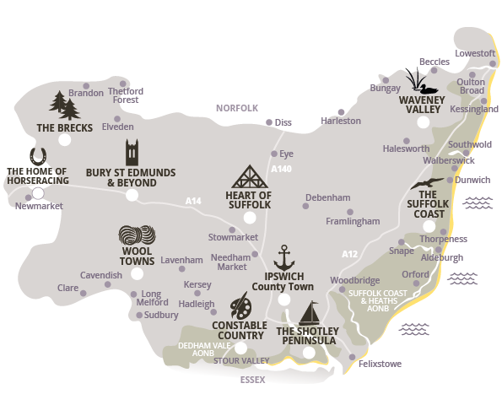

**INDEX**

1. **Welcome and Introduction page 2**
2. **The Opportunity page 3**
3. **The Situation page 5**
4. **Your Colleagues page 8**
5. **The Deanery of Woodbridge page 9**
6. **Accommodation page 10**
7. **The Diocese of St Edmundsbury & Ipswich page 11**



26222

July 1, 2021

Deanery of woodbridge

Diocese of St Edmundsbury and Ipswich

1. Welcome and Introduction

## **Here in the Wilford Peninsula we are changing the way we focus our mission and ministry which we know will mean a different approach to worship and praise complementing existing more traditional services. Read on and feel the excitement of possibilities and opportunities this role offers as we shape and deliver a benefice-wide strategy on mission for our young people and families as part of a diverse and focussed body of disciples. Applications are open to lay and ordained people.**

# Background

### The Wilford Benefice, one of the largest in the Church of England, covers 18 churches in the beautiful Wilford Peninsula on the Suffolk Coast 16 miles north-east of Ipswich. We have six primary schools of which three are Church of England supported.

### You will be a key part of the team which, in a benefice of this size, necessitates a different approach to ministry and mission. We have a genuine belief in the concept of working together and supporting each other with flexibility and recognition. Lockdown has only deepened mutual respect as we embraced new ways of communicating and bringing God to those who might otherwise be marginalised or forgotten. The strengths we have discovered will change the journey ahead and we cannot wait to welcome another valuable member to enable us to “Grow Younger” in our mission.

## **Is this role for you?**

## **Do you have a desire to focus in your work on leading young people’s and families’ mission in a diverse rural context as part of a supportive team? Keep reading and if you share our excitement and want to learn more contact us to begin your next adventure.**

### With all blessings

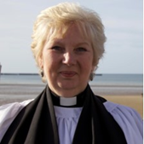

Revd Giles Tulk Revd Mandy Reynolds

Team Rector Team Vicar

1. The Opportunity

# What we are looking for

### This is a new position offering real opportunity for the right person.

### We feel that God is moving us towards young people and families’ ministry and outreach and see this as being key to growing the kingdom of God in our benefice. We are clear that for this to be successful, we need someone who will champion this vital part of our shared mission and ensure it is always top of our agenda.

### We are already a strong discipleship of hundreds of adults, tens of whom are directly involved every week in the delivery and dissemination of the Word. Despite the impact of the pandemic there is a vibrancy and a feeling of progress, a testament to the commitment to shared values and team spirit. You will need to be a true team player, a leader of initiatives, sharing ideas and learning from others.

### Living in Hollesley, one of our three Mission and Ministry Centres, you will be involved in local communities, activities and worship across the Benefice.

### Above all, we are praying for someone with a real passion for and experience of mission and outreach with young people and families who would be prepared to drive, shape and help deliver our strategy to “Grow Younger”. This all fits with a wider strategy of reaching out to communities we have not reached before through our “Lightwave” initiative.

# What we offer

### Our Church will be warmly supportive and will genuinely encourage you to take risks in leading ministry with young people and families. There will be opportunities for formal and informal learning together with a framework for personal development and mentorship. Relevant courses and retreats will be part of your schedule.

### Your personal targets will be mutually established to be achievable in the terms of your working agreement always returning to your primary focus and allowing for rest days and holidays.

****The diocese of St Edmundsbury and Ipswich strongly encourages all incumbents to promote the growth of small missional groups and fresh expressions of Church. ‘Lightwave’ has been created with a diocese-wide Bishop’s Mission Order to support clergy and lay people to work together in mission-shaped communities, reaching out in innovative ways.

The Lightwave Community meets in small groups in homes, pubs, offices, schools and other places and complements other ways of being church, committed to shining the light of Jesus in Suffolk through acts of kindness and practical service as well as worship and witness.

Each Lightwave group works together to bless their local community and to share faith in their locality or network. Groups receive support and training in their outreach through a growing network of coaches. <https://www.light-wave.org/>

1. The Situation

# The Parishes of the Wilford Benefice

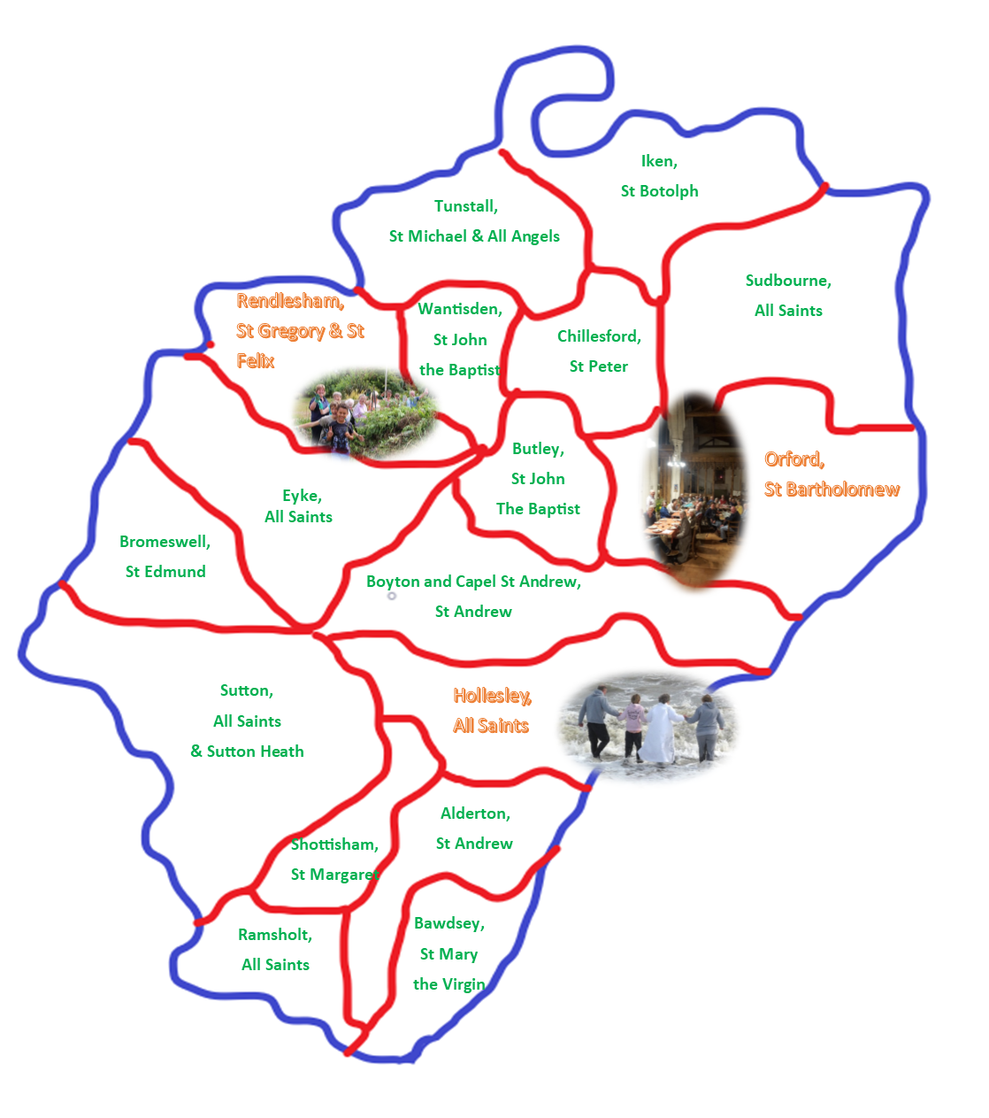

For further information on each parish go to <https://www.achurchnearyou.com/>

# Our Churches

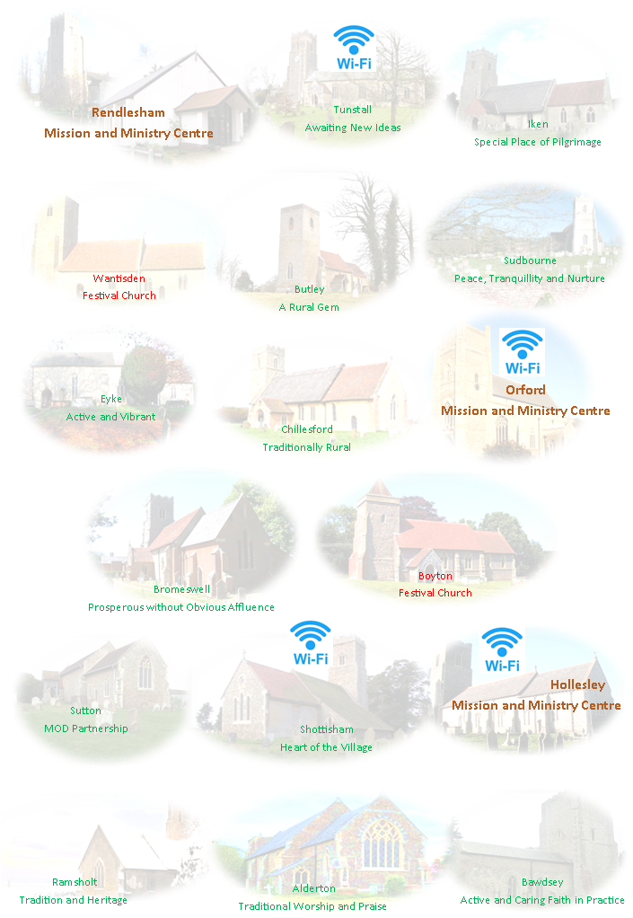

For further information on each church go to <https://www.achurchnearyou.com/>

# Our Schools

We are lucky to have six Primary schools within the benefice which can make an excellent starting point for building links with families. Three are State maintained (Rendlesham, Hollesley and Sutton Heath Sandlings) and three either voluntary aided or controlled by the Church of England (Bawdsey, Eyke and Orford)

Pupil numbers in these rural schools range from 50 to 300 . Although some are situated in relatively affluent areas there is a rising percentage of children living in rural poverty for whom the church could be a lifeline.

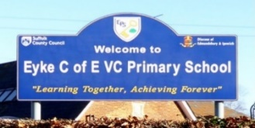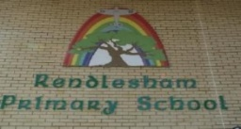

**Orford** CEVA primary School and **Bawdsey** CEVC Primary School work closely together. Our Team Rector Giles is on the board of governors for both schools and has an excellent relationship with the executive head and her staff. During the pandemic opportunities for school visiting have been more limited but the children and their parents have enjoyed zoomed Bible stories and assemblies. The Christmas service, zoomed from Orford church, attracted some 60 family groups. Over the Christmas period a ‘Nativity Treasure Hunt’ was organised around Orford and it was heartening to see many of the local families taking part.

**Eyke** C of E Primary School, is a Diocesan Multi Academy Trust school with approx. 120 pupils and situated close to the Church of All Saints, there is a happy and close relationship between the two. The children attend church weekly for assemblies, all major festivals and special school occasions. Team Vicar Mandy sits on the Board of Governors and is welcomed into school to help with appropriate activities. Many of the children live in Rendlesham and enjoyed joining in with after school activities in the Church of St Felix.

**Rendlesham** Nursery and Primary School is situated in the heart of Rendlesham and has approx. 300 pupils. It has no religious affiliations and has not in recent years had any relationship with the Church. The new headteacher presents an opportunity here.

**Sandlings** Primary School is located within Sutton Heath Estate adjacent to Rock Barracks, home of 23 Royal Engineers. The school is multicultural and has a large proportion of military children. The school has no religious affiliations, however, there is a growing relationship with Mandy, herself experienced as a Military Chaplain.

**Hollesley** School comes to Church (pre-pandemic) for special services at Christmas, Easter and Harvest and also for educational visits hosted by the Churchwardens. “Church Club” was, and hopefully will again be, a popular choice in the After-School programme on Thursdays. There are plans to establish a junior choir when appropriate.

# Our Communities

### [Messy Church](https://pbs.twimg.com/profile_images/958738895889367041/l0HjqVMb_400x400.jpg)Contact with children and families is at the heart of our mission to ‘Grow Younger’, building on our close collaboration with all our primary schools through Open the Book, Messy Church and church-based after school clubs. We aspire to continue and grow our contact with schools through governorship and support with RE learning and collective worship. The 'Fizzers' group encouraged teenagers in Christian Discipleship, and we hope to work more closely with uniformed organisations in the benefice.

### 

### Hollesley PCC run an After School Club during term time, when permitted for the children at Hollesley Primary School. Activities include Games, Craft, Bible teaching, food, and prayers.

***“Soul Survivors” 2019***

### 

### We have been fortunate in that Just42 *“the only open access youth provider in 200 square miles of rural Suffolk”* visits our villages “*To deliver innovative, high quality and professional youth and children's work and to facilitate the social, emotional, physical and spiritual development of young people and children.”* **Just42.org.uk**

### There are two choirs in the Benefice centred in **Orford** and in the Southern **Deben 8** parishes.

1. Your Colleagues

# Our discipleship is extensive and theologically wide-ranging. Together with the Team Rector and the Team Vicar we have five further priests with Permission to Officiate, two Readers, fifteen Lay Elders and at least twenty other members of Church Family with jobs to do amongst the team.

**Lay Elders began in our Diocese in the late 1960s as a pioneering experiment in lay ministry in our North Suffolk Deanery. Their ministry was developed and expanded so that by now there are over 500 Elders, spread across the whole Diocese.**

**Elders are men and women chosen by the local Church and authorised by the Diocesan Bishop for ministry in the local Church and community. They work mainly in the area of pastoral care and/or leading worship.**

**Their Commissioning takes place at any appropriate date in their parish Church.**

**They serve initially for a maximum of three years and may be re-commissioned for further periods of up to three years.**

**Anyone who is baptised and confirmed, a regular communicant, in good standing in the local Church and community, and able to fulfil the tasks of an Elder, may be considered for this ministry. There is no lower or upper age limit.**

**Lay Elders are unique to Suffolk, so they are not named in Canon Law. However, their ministry falls within what Canon Law permits lay people to do. In effect the ministry of Lay Elder gathers into a coherent ministry, valid in its own right, what Canon Law permits lay people to do occasionally.**

**lay elders**

# Clergy and Readers meet at least monthly to share ideas, plan activities and provide mutual support. Meetings have continued throughout the pandemic through the medium of

# Networks exist throughout the benefice for those with specific roles such as Treasurers, Churchwardens, PCC Secretaries and Elders.

# Our Benefice Safeguarding Officer and Administrator are invaluable in keeping us safe and connected.

1. The Woodbridge Deanery

## This is an exciting time for Woodbridge Deanery. Over the last eighteen months four of our six stipendiary clergy retired and recent new appointments have brought fresh ideas and opened up future possibilities of support and encouragement. New members have also brought renewed energy and commitment to creating a supportive and friendly Chapter in person and on Zoom.

## The Deanery is facing many new challenges as we support each other through COVID-19 and beyond. We are reviewing new possibilities for working together and have all learned much about live streaming worship and the benefits and pitfalls of virtual groups and meetings. Within the five benefices we now have several Little Pantries and in the town of Woodbridge a Food bank based in the Salvation Army and supported by Churches Together.

## A major task in 2021 will be to create a new vision for the deanery plan as we seek to be faithful in mission and ministry in each of the 32 parishes; many of which are small and rural. There are great opportunities for rural networking and sharing ideas as we seek to “Grow in God”.

## The deanery looks forward to welcoming you to your new post in the Wilford Team.

Ven Annette Cooper

Rural Dean of Woodbridge

# https://www.cofesuffolk.org/uploads/Growing_in_God_-_Plain_lrg.png**Our priorities for mission in the benefice are inspired by the diocesan vision of Growing in God. We are called both to preserve and grow the rural church as a focal point of each community through pastoral visiting, engaging with community initiatives, a long-standing tradition of choral and music celebrations and encouraging the imaginative use of our wonderful church buildings. We aspire to improve communications across the benefice through the judicious use of websites and social media.**

1. Accommodation

# Location

## Your home will be in the heart of the village of Hollesley, one of the larger villages in the Benefice. Hollesley is a working community with rural businesses, mixed housing and consequent mixed population many of whom work locally including at Hollesley Bay and Warren Hill Prisons, about 1.5 miles away. There is a ‘Good’ Primary School, a Public House and a Village Stores with Post Office.

# The Vicarage

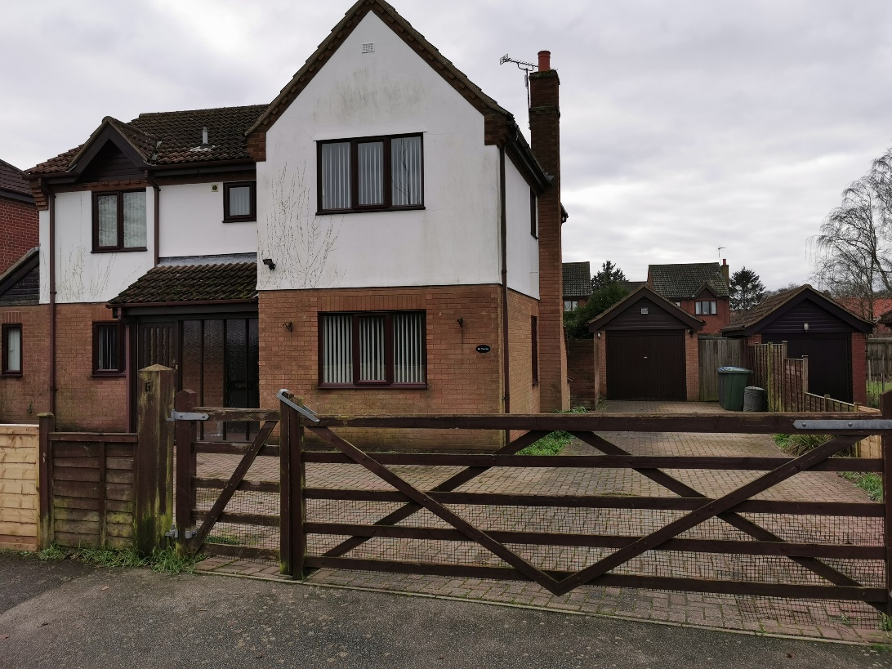

## A modern, recently redecorated and upgraded two-storey family home with an enclosed rear garden, front yard and garage.

## The oil-fired centrally heated home with solar assistance comprises;

* Lounge with doors to rear aspect
* Large kitchen and utility room
* Study with bookshelves
* Rear conservatory
* Downstairs WC
* Master bedroom with en-suite shower room
* Three further bedrooms and family bathroom



# **Where are we?**

The Diocese covers the county of Suffolk, excluding the area around Lowestoft in the north-east, and one parish in Essex. It is a mainly rural Diocese with a large number of small villages, plus market towns including Woodbridge, Halesworth, Sudbury and Beccles and the cathedral town of Bury St Edmunds with its historic ruins of the old Abbey. Ipswich is the county town with a population of about 137,000. Suffolk’s population is c 650,000. The county embraces historic places of interest such as Sutton Hoo, culture at Snape with the famous annual Aldeburgh music festival, is on the Heritage coast and is a haven for lovers of natural history and birdlife. The busy port of Felixstowe is at the end of the A14 which runs via Cambridge to the Midlands and the A12 which gives access to London and the Norfolk Broads.

# **Who are we?**

We are often known as ‘the Church of England in Suffolk’. The diocesan bishop is the Right Reverend Martin Seeley, and the suffragan bishop is the Right Reverend Dr Mike Harrison. Both work from the Bishop’s House in Ipswich. They work together closely to help us shape our vision and strategy, and amongst a plethora of other tasks offer regular teaching mornings to nurture the faith of people in our congregations – and a regular Vlog which can be found on Facebook. There are 3 archdeaconries and over 450 churches where visitors will find a wide range of worshipping styles, from the traditional to contemporary, as well as Fresh Expressions and growing numbers of ‘Lightwave’ groups for those who haven’t connected with traditional church previously. The Cathedral of St Edmund and St James in Bury St Edmunds is the mother church of the Diocese and is proactive in offering support to clergy and parishes including welcoming parishes on pilgrimage. We also work closely with our 88 Church of England primary schools. All this is, of course, supported by a small and committed diocesan staff based in the diocesan office in Ipswich.

# **What is our vision?**

Our diocesan vision is to be ‘Growing in God’, aiming to grow ‘flourishing congregations making a difference’. This vision was accepted by Diocesan Synod in 2014 and since then we have been focussing on four key priorities:

* **Growing in Depth: responding to the call of Christ in every part of our lives**
* **Growing in Number: drawing the contacts we have into the life of God’s kingdom**
* **Growing in Influence: reaching beyond ourselves in our impact on the wider world**
* **Growing Younger; building churches whose age-range reflects our communities**

Parishes are encouraged to use a simple Mission Action Planning tool to help us all to focus on these priorities and how they might be worked out in each different context. We are trusting God that this vision, underpinned by a commitment to Christian stewardship, will bear fruit as we look to the future.

As part of this vision, we have recently received Strategic Development Funding for two major projects: Inspiring Ipswich, overseen by the Archdeacon of Ipswich which aims to grow the church in Ipswich though church planting and reaching out to those who live in the town, and ‘Growing God in the Countryside’, overseen by the Archdeacon for Rural Mission, which focusses on developing Rural Resourcing Churches and nurturing and discipling new Christians through small Lightwave groups.

We have also been part of a pilot scheme exploring how we can use our church buildings more creatively both for those who worship regularly and for the benefit of our communities and many churches have benefitted from this.

We are broadening our vision through a growing partnership with the Diocese of Kagera in Tanzania, with fruitful visits and links being established.

# **How can we do this?**

We value our huge range of different ministries: we have over 100 stipendiary clergy, plus many SSM and PTO clergy as well as lay and ordained chaplains who can be found in such diverse places as schools, prisons, hospitals, hospices, the army, RAF and the police. Some clergy are ordained to serve in their local benefice through our pioneering ‘auxiliary ordination pathway’ which enables people’s vocations to ordained ministry to be discerned within the Diocese.

All clergy work alongside lay ministers – Readers, elders, and the growing number people exercising recently introduced licensed ministries: pioneer ministers, evangelists, youth ministers and children’s and family workers. Our ministry deployment principles encourage teams or clusters of lay and ordained ministers to work together so that clergy feel less isolated and ministry resources the mission of the church more effectively. We are just beginning to develop the principle of ‘local ministers’ in our benefices, releasing people’s gifts to serve in their locality.

We are excited about these new developments which are playing an important part in our diocesan vision of Growing in God.

# **So, in summary:**

As our Growing in God vision states, we aspire to be people who know that ‘God is with us, gathering us as Christ-centred communities, calling us to make Christian disciples, sending us in loving service, empowering us by the Holy Spirit’.

# **We hope you will come and join us on our journey!**

# **To find out more, visit:** [**www.cofesuffolk.org**](http://www.cofesuffolk.org)