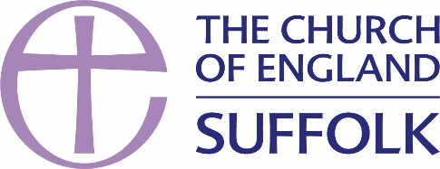

Free Wills: Information & Access to Farewill

The National Church and the Diocese of St Edmundsbury & Ipswich have teamed up to offer free online wills through Farewill. Online wills will not be for everyone so below is some information about finding alternative suitable will writers.

Farewill

Farewill are now the largest and most trusted will writer in the UK, voted National Will Writing Firm of the Year at the British Wills and Probate Awards in 2019, 2020 and 2021. They are proud to have over 8,000 reviews on Trustpilot and an average score of 4.9/5 stars; the highest Trustpilot score for any legal or financial services business globally.
Farewill has developed a bespoke will writing journey with the Church of England which allows people to easily find their local churches for legacy giving (in connection with A Church Near You). Farewill offers both online and telephone will writing – the Church of England partnership offers free online wills only.
There is no obligation to anyone using the service to leave a gift in their will to their local church, but we hope that people will consider making a gift to further their local church’s mission and ministry, or to another church they support.
No personal data will be shared between Farewill and the Church of England and wills are written by Farewill in the strictest confidence. Farewill's specialist team are available to help you over the phone or live chat 6 days a week, 9am-7pm. Every Will is proof-read and checked by their specialist wills team.
- Click on the link to find out more about Farewill and making an online will. How-To guide: https://farewill.com/guides/how-to-make-a-will

- If you would like to access a free online will with Farewill please click on this link www.farewill.com/edsandlps-diocese.

Farewill’s Promise to You
We will respect your privacy at all times. By writing your will with Farewill, your details will not be shared with the Church of England. If you use the Church of England will writing scheme, there is no obligation to leave a gift to a church in your Will. Your loved ones should always come first. If you do choose to remember your local or a favourite church, thank you. Every gift, great or small, will make a real difference to that church and its mission and ministry in your community for future generations.

Parishes should add this information and link to their church legacy information so people can access free wills.
More information about finding a will writer

The Law Society has a database of solicitors authorised to practise by the Solicitors Regulation Authority. Using their postcode search function, you can view a list of all local Solicitors.
Click here to find your local solicitor.

If you wish to seek a Christian lawyer or legal advice, the Lawyer's Christian Fellowship have recently launched a free service to search their directory of members.
Find a Christian solicitor.

Low-cost Will writing options
Wills are legal documents, and as small errors can cause big problems, it’s vital to have someone legally qualified draft it for you. There are however a number of low-cost solicitor wills as well as individual and charity-based schemes available.
Read Money Saving Expert's guidance on Cheap and Free Wills.

