Safeguarding Training Strategy
2024-2027

Introduction
Parish life is at the heart of the Diocese, and a healthy Christian community is one which ensures and nurtures the wellbeing of all. Safeguarding therefore, needs to be embedded in all aspects of the life and ministry of the Church to ensure that the culture of safeguarding is integral throughout all our church communities. The facilitation and delivery of safeguarding training and development within the Diocese of St Edmundsbury and Ipswich is an important part of this. It is essential, therefore, that churches and church officers understand safeguarding as a theological imperative, rooted in the nature and love of God, integrated with pastoral care, and treating those who are most vulnerable appropriately, with respect and dignity.
Effective safeguarding learning is one of the key means by which we will become a safer and healthier Church, and the learning pathways in the framework aim to achieve this.
The House of Bishops policies and practice guidance require dioceses to offer consistent training in safeguarding for clergy, and other diocesan officers including all those who hold the Bishop’s licence. Although there is no statutory requirement for this training, there is an expectation in Government Guidance that all staff, volunteers and officeholders know what to do should safeguarding situations arise. There may also be issues of insurance and vicarious liability should training opportunities not have been made available to parishes by the Diocese, together with robust encouragement to access it. The costs for this training are fully covered by the Diocese for diocesan officers and members of congregations in the Diocese.

Content
Training will be focused on building healthy communities with a culture of safety, in which the wellbeing of all is ensured and nurtured. Modules reflect the national requirements across all dioceses for ensuring healthy safeguarding practice, responding well to victims and survivors of abuse in the church context. They emphasise the need to work in co-operation with the Diocesan Safeguarding Officer and with statutory agencies in all safeguarding matters. Training for all church roles will include safer working practices which emphasise the importance of maintaining proper boundaries and a culture of “respectful uncertainty”.
Although in the past, “safeguarding” was considered very much in the light of “Child Protection” it is now seen to have a much wider remit, addressing the needs not only of children and young people, but also of adults. In the church context, adult vulnerability may be identified through specific conditions, such as disability or ill health, or because of specific situations, for example because of a miss-use of power within a local context. Within the Church, all are welcomed, including those who pose risk; and in most situations, church officers will be unaware of any risks posed. The Church is therefore uniquely challenged to provide a safe environment for all who attend, especially children and those who are vulnerable.

Training Arrangements
Safeguarding training is to be led and delivered by appropriately trained, experienced and skilled trainers who understand the statutory requirements of safeguarding children and adults, and how these are carried out within the church context.
The Safeguarding Training & Development Framework provides the framework for safeguarding learning and development across all Church of England communities. It also sets out the core safeguarding learning pathway training modules which are a mandatory requirement determined for clergy, for those holding licence to officiate as well as for specific church roles and responsibilities.
It is recognised that participants need the opportunity to reflect and explore with the trainer as well as with one another, some of the particular and complex challenges which they face in their work with children and adults who may be vulnerable. Participants may also have vulnerabilities due to having experienced abuse in the past, and trainers will need to be both aware and sensitive in taking this into consideration, whilst making provision for any attendee who may become distressed.
Those participating in training are also likely to need some opportunity to reflect on the relationship between safeguarding issues and their beliefs as articulated in theological language if safeguarding learning is to become thoroughly integrated with their behaviour, relationships, and culture within the life of the church.

Training Delivery
Training is delivered by the Diocesan Safeguarding Trainers, with support from recruited Volunteer Trainers, at accessible venues, including online, and in the Diocese.
There are three levels of Volunteer Trainer. All potential Volunteer Trainers, regardless of other roles they may hold within the diocese, are appointed using the Safer Recruitment process. Once in place they are assigned to a supervising trainer, who is usually one of the diocesan trainers. They take part in a training programme appropriate to the level of Volunteer Trainer their role is. They continue to be supported and monitored in their work by their designated supervising trainer.
Level One Volunteer Trainer:
- Using the online training modules provided by the National Safeguarding Team they can facilitate the training for up to 3 people at one time.
- Modules they can facilitate include Basic Awareness and Foundation.
- Level One Trainers may extend their role to include being able to facilitate the Raising Awareness of Domestic Abuse module once they have received further guidance and approval from their supervising trainer.
Level Two:
- Using the resources provided they can deliver in-person training.
- Modules they can deliver include Basic Awareness and Foundation.
- Once fully trained and ‘signed-off’ by their supervising trainer, they can deliver training on their own, whilst being supported by a suitably qualified pastoral lead. For example, a member of Clergy, Elder or Safeguarding Officer.
- If working with another trained deliverer, either Volunteer or Diocesan trainer, they can work with larger groups of participants.
- Group sizes for participants are set for all trainers by the National Learning and Development Framework.

Level Three:
- Works alongside a Diocesan Safeguarding Trainer to facilitate Leadership training.
- They will be a supporting trainer during these sessions, helping to facilitate discussions and small group tasks.
All Volunteer Trainers are responsible for informing the diocesan training team of the arrangements they make for training events. This includes details of who attends so that appropriate certificates can be issued, and records maintained.

Minimum requirements
The Bishop of St Edmundsbury and Ipswich through acceptance of this House of Bishops Practice Guidance, has set minimum requirements for safeguarding training for ordained, licensed and other church officers. A “church officer” is anyone appointed by or on behalf of the Church to a post or role, whether they are ordained or lay, paid or unpaid.
Those requiring core training – see fig:2 for which training is required – include:
- All those who hold the Bishop’s licence, commission or permission to officiate (this includes Deacons, as part of IME; new incumbents/stipendiary clergy new to the Diocese, as part of CMD; non-Stipendiary Ministers; Readers; Lay Elders; Commissioned Lay Pastoral Assistants, as part of training and pre licensing/commissioning; those applying for Bishop’s Permission to Officiate
- All Diocesan and Cathedral staff/volunteers
- Children and youth workers employed or volunteering within the Diocese or in parishes
- Parish Safeguarding Officers
- Churchwardens
- Anyone else who has significant contact through their role in the Church with children, young people or adults who may be vulnerable to abuse or exploitation, or who needs a DBS check in order to carry out their role for the Diocese or a parish.

A bishop may not license a reader or lay worker unless the bishop is satisfied that the candidate has undergone specifically designated training validated by the National Safeguarding Team. This will include training related to the safeguarding of children and vulnerable adults. In addition, Working Together 2023, the government guidance on how organisations address child protection issues, sets out that all “staff should be given a mandatory induction, which includes familiarisation with child protection responsibilities and the procedures to be followed if anyone has any concerns about a child’s safety or welfare”.

Current courses
The Diocesan Safeguarding Team set the annual training programme to reflect the training requirements of all diocesan members, with due regard to the requirements and Guidelines as outline by National Learning and Development Framework about who should do what training.
The jigsaw graphic below gives an overview of the courses that make up the training from the National Team.
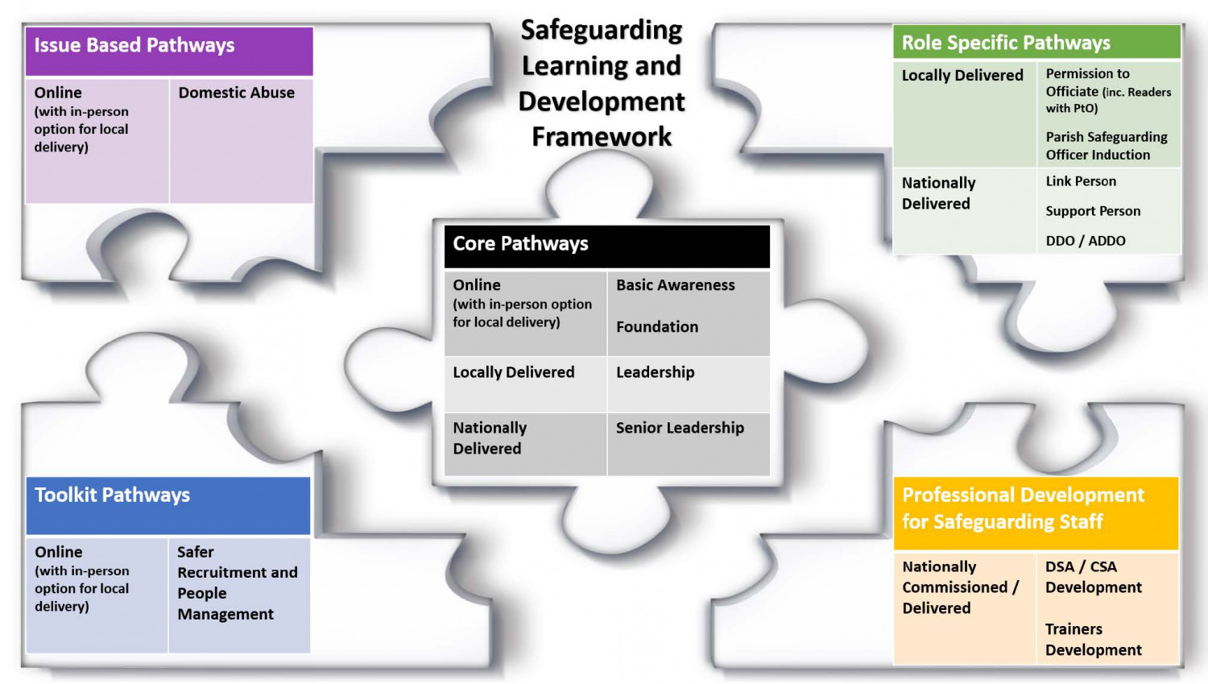
Fig: 1 – The Safeguarding Learning and Development Framework showing Training Pathways

The annual training programme will include the following pathways, as described in the National Learning and Development Framework:
Basic Awareness and Foundation
- Available online via the National Training Portal.
- Delivered in-person by Diocesan and/or Volunteer Trainers where participant numbers are in accordance with those set by the National Learning and Development Framework.
- Training sessions are spaced through the year and across the diocese to allow for maximum access and participation by members.
Leadership
- Available both online (via Zoom) and in-person.
- Delivered by one or two Diocesan Trainers, depending on participant numbers, ensuring fidelity is kept by keeping to the ratios set out in the Learning and Development Framework.
- Training sessions are spaced through the year with those that are in-person being located across the diocese to allow for maximum access and participation by members.

Raising Awareness of Domestic Abuse
- Available online via the National Training Portal.
- Delivered in-person by Diocesan Trainers, accompanied by an experience pastoral leader who is available to support any individual who may need care and attention due to issues triggered by the course material.
- Training sessions are at the request of incumbents/safeguarding leads who require sessions to be delivered for participants who are unable to access the online resources for a variety of reasons.
Modern Slavery and Safer Recruitment & People Management
- Available online via the National Training Portal.
The remaining modules shown by the jigsaw graphic are not currently delivered within this diocese. Therefore, alternative support is given, or courses recommended to ensure all members are appropriately trained for their role. For example, all members with PTO are required to complete the Leadership pathway which covers all, and more, of that in the Permission to Officiate pathway.
Attendance at all facilitated courses (in-person sessions, and those delivered via Zoom) must be booked in advance.
The table below gives an overview of current courses offered in the Diocese, and the expectation of who should complete them:
 | Core Training Modules |  |  |  | Specialist Training Modules
 | Core Pathways |  |  |  | Issue Based Pathways
 | Basic Awareness | Foundation | Leadership | Senior Leadership | Raising Awareness of Domestic Abuse
Those holding the Bishop’s license, commission, authorization or permission; Ordained or Lay:
Bishops & Honorary Bishops | P | P | P | P | P
Bishops’ Chaplain | P | P | P | P | P
Archdeacon | P | P | P | P | P
Deans | P | P | P | P | P
Incumbents/Priest-in-Charge | P | P | P |  | P
Permission to Officiate (PTO) | P | P | P |  | P
Curates | P | P | P |  | P
Licensed Lay Minister | P | P | P |  | P
Lay Elders | P | P | P |  | P
Ordinands | P | P | P |  | P
Readers | P | P | P |  | P
Leaders in Lightwave Groups, Fresh Expressions or any other group gathering:
Lightwave Leader/Assistant Leader | P | P | P |  | P
Licensed Pioneer / Outreach Pioneer | P | P | P |  | P
Chaplaincy Team Member | P | P | P |  | P
Church Officers and Role Holders including:
Safeguarding Officer (Benefice/Parish/Cathedral/Lightwave) | P | P | P |  | P
Spiritual Directors | P | P | P |  | 
Church Wardens | P | P | P*
PCC member | P | P |  |  | PR
Chapter / Cathedral Trustee | P | P |  |  | PR
Directors of Music | P | P | P | P**
Choir Leaders / Music Group leader | P | P | P***
Bell Tower Captains | P | P | P****
Servers | P
Vergers | P | P
Volunteers/staff: working with children, young people, or vulnerable adults including:
Supervisors of work with children/young people/vulnerable adults.  Examples include:  - Sunday School Leader  - Messy Church Leader  - Dementia Café Leader  - Open the Book Leader  - Youth Group Leader | P | P | P*** |  | P
Assistant/helper working with children/young people/vulnerable adults  Examples include:  - Sunday School Helper  - Messy Church Helper  - Dementia Café Helper  - Open the Book Helper  Youth Group Helper | P | P |  |  | P
House Group Hosts/Leaders | P | P | P*** |  | P
Church Volunteers and Group Members including:
Welcomers | P
Refreshment helpers | P
Flower arranger | P
Choir Members/Music Group members (inc. sound/AV) | P
Organist / musician | P
Bell ringers | P
Church Administrative Staff | P
Caretakers | P
Lightwave group helper | P
Occasional Helpers | PR
DBF Employees and Associates
DSAP Members | P | P
Diocesan Secretary | P | P | P | P
DBF Staff | P
Director or Mission & Ministry | P | P | P | P | P
HR Director | P | P | P | P | P
Safeguarding Team Members; Training | P | P | P |  | P
Safeguarding Team Members; Administration | P | P | P |  | P
Safeguarding Team Members; DSO & ADSO | P | P | P | P | P
Fig: 2 – A table showing current courses and who should complete them. Please note, this table is not exhaustive. Anyone holding a role not specifically listed here is required to undertake Safeguarding Training appropriate to the specifics of their job role.

* It would not normally be expected that the role of a Church Warden requires Leadership training, however if the parish is in Vacancy, or if the Church Warden leads services, they will be required to complete their Leadership training.
** There are some holders of the title ‘Director of Music’ within small parish churches, where their role does not include many of the responsibilities connected with that of a Cathedral Director of Music. Therefore, all directors of music should be assigned an appropriate training level dependent on their job role rather than job title.
*** The role, responsibility and influence of group leaders varies across parishes. If the group leader can “significantly influence the culture of that Church body” they must complete the Leadership module.
**** Work with the Suffolk Guild of Ringers continues to add clarification for all Bell Tower Captains. As with directors of Music, their job role varies from parish to parish therefore their required level of training is determined by job description rather than job title.
PR It is recommended that people in this role complete this level of training. This is a recommendation and not a mandatory requirement.
“Safer Recruitment and People Management” is a training module in the Toolkit Pathway, available online via the National Portal. All people in any role that is involves the recruitment of volunteers or paid staff should complete this module. For example, interview panel members for a member of clergy, Parish Safeguarding Officers and Clergy who are recruiting congregation members to join parish groups such as those that work with children, young people or vulnerable adults.

Evaluation and review
All courses will be based on those set as Core and Specialist Modules as part of the Safeguarding Training and Development Framework. A record of attendance will be kept by the Diocesan Safeguarding Team, and it is expected that parishes will also keep a record of those in key roles who have completed the requisite training for their role. The responsibility for ensuring that the requisite training is undertaken, and updated at the appropriate interval, lies with the appointing individual or body, together with the postholder of the role/position held.
This Training Strategy is evaluated, reviewed and adjusted annually in response to new legislation, policies and guidance as advised by the National Safeguarding Team, and feedback from previous training sessions.

