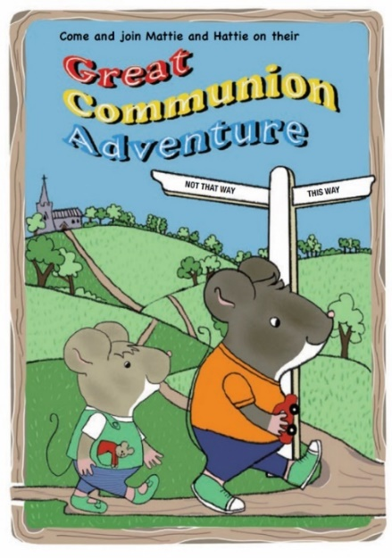
Mattie and Hattie books
Order form

Books are £4 each. Postage costs vary according to the number of books ordered:
1 - 2 books £1.31
3 – 5 books £1.73
6 – 7 books £2.39
8 – 20 books £2.85
More than 20 books poa
I will collect from Diocesan Office, 4 Cutler Street, Ipswich IP1 1UQ ☐ Free from postage costs
please tick if appropriate

 | Number required | Cost per book | Total cost
The Great Communion Adventure |  | £4
The Great Baptism Adventure |  | £4
Postage (see above) | See above
Total

Your name __________________________________________________________________
Email address _______________________________________________________________
Parish name _________________________________________________________________
Delivery address _____________________________________________________________
_____________________________________________________________________

If possible please send payment for the total amount by BACS to
Sort code 16-22-17 Account number 12190090
St Edmundsbury and Ipswich Diocesan Board of Finance
Reference: MatHat your name

If you need to send a cheque, please write MatHat CHIL 16002 on the back and make payable to
St Edmundsbury and Ipswich Diocesan Board of Finance
Please return this form to lesley.steed@cofesuffolk.org. Call 07485 348889 with any queries.

