How to electronically sign a PDF Form:
Complete the main details on the form as stated.
For the Signed & Verified section:
- Double click on the ‘Sign’ cell.

- This will bring up the pop up detailed below:

- Select I want to sign this document using - ‘A new digital ID I want to create now’. Then select next.

- Choose how you would like to store your self signed digital ID

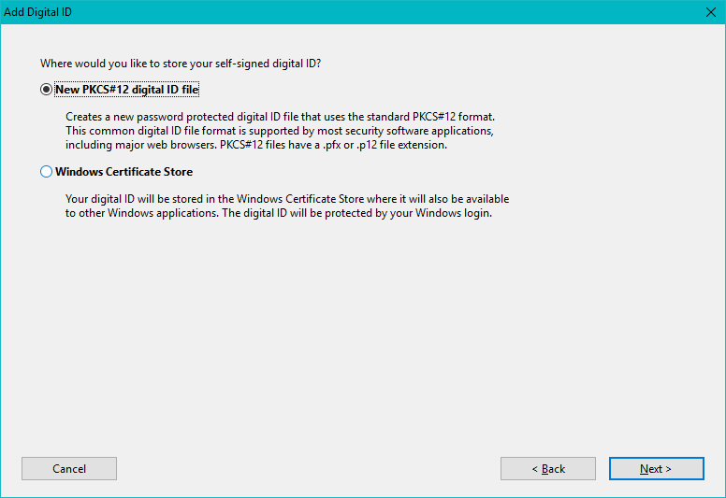

- Select next.

- Enter your details as requested.
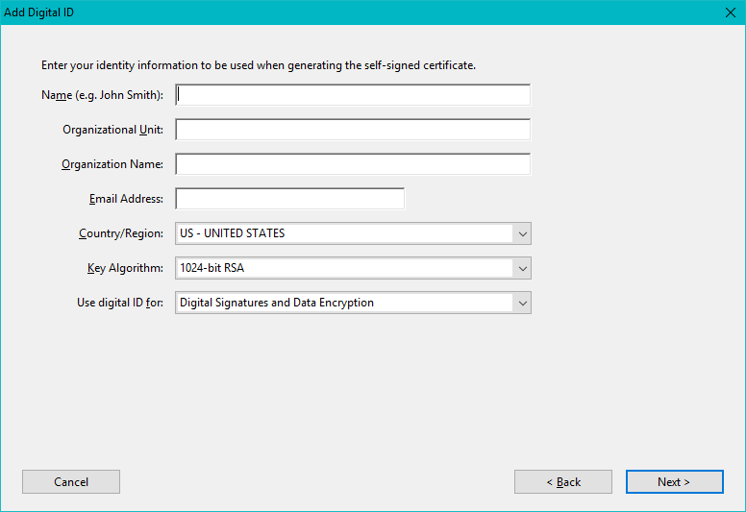

- You will be prompted to set up a new password.

- Select finished.

- You will then return to the ‘Sign’ cell.

- Double click on the cell and enter your password and this will be what you see:

- The form is now signed.
This change form can then be sent electronically to next signatory to sign. For change requests please send to info@parishgiving.org.uk please submit completed registration forms to your Diocese.

