LKS2 What symbols and stories help Jewish people remember their covenant with God?
What should we know?
Covenant means promise.
Jewish people believe:
- The rainbow is a sign of the first covenant with God.
- Abraham was called into a covenant with God.
- The Exodus was God’s rescue of the Jewish nation from Egyptian slavery.
- God summoned the Jewish people to Mount Sinai to renew their Covenant with them.
- God’s covenant is remembered at Passover.

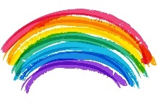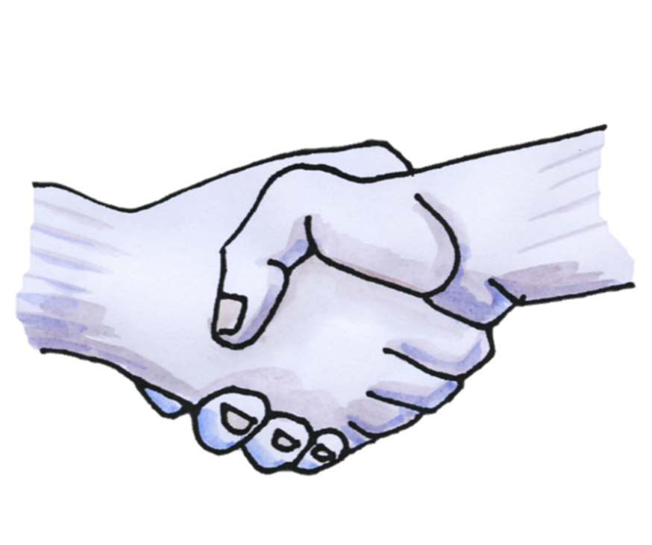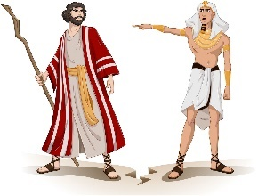
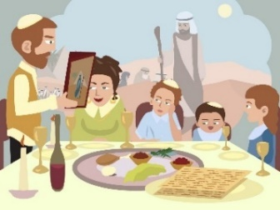
Prior learning
Jewish people believe good deeds like helping others are important.
Jewish people say prayers and blessings to God.
Shabbat is a day of rest.
At New Year God gives people a chance to put things right.
The Torah is an important book.

What should we be able to do?
Use religious words to describe how a rainbow in the Noah story is a reminder of God’s promises.
Explain how a mezuzah links with remembering God’s covenant.
Describe what Jewish people might learn from the stories of Abraham about a covenant with God.
Describe some different customs and practices Jewish people have as part of their Passover celebrations.

“This is the sign of the covenant which I make between me and you and every living creature.” -Genesis 9:12

The Exodus from Egypt.

The Passover meal.

What words should we understand and be able to use?
Exodus | The story of the Jewish people being rescued from slavery in Egypt. | Shavuot | A celebration of the day God gave the Torah to the Jewish people.
Passover | The festival celebrating the freedom of the Jews from slavery in ancient Egypt. A time of great joy. | Omer | Between the holidays of Passover and Shavuot, the Omer is counted each evening.
Seder | The Seder is a feast that includes reading, drinking wine, telling stories, eating special foods, singing, and other traditions on the first night of Passover.

