**KS1 Why do Jewish families say so many prayers and blessings?**

**What should we know?**

Jewish people:

* Say prayers and blessings to God because it reminds them how great God is.
* Say thank you to God for all he provides.
* Have a day of rest each week called Shabbat.
* Pray at both home and the synagogue.
* Sometimes wear special clothes.

**Prior**

**learning**

Jewish people believe good deeds are important.

**HELP** others in need.

**WELCOME** others.

**GIVE** money to help other people

**CARE** for the world.

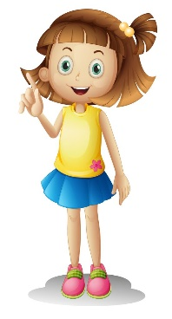** 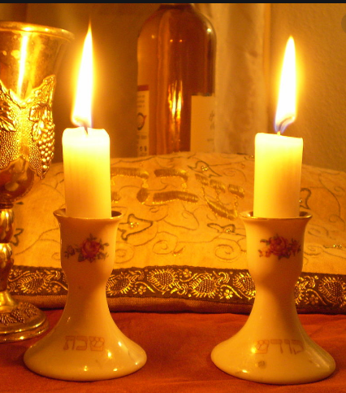

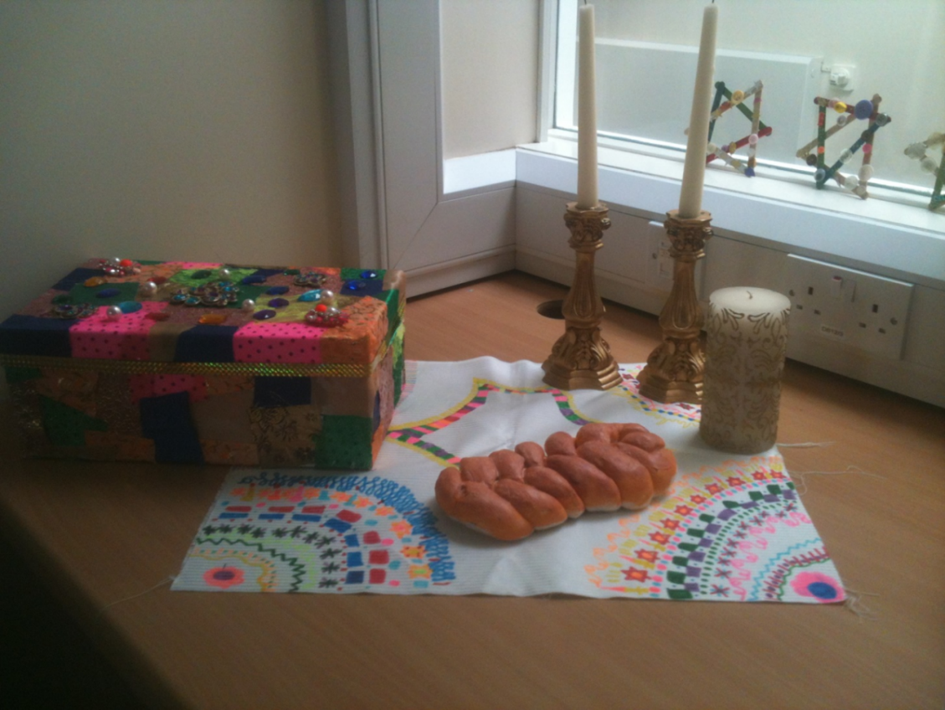

**What should we be able to do?**

*Recognise a Jewish sukkah.*

*Recall when a Jewish person might say a special blessing.*

*Describe what is special about Shabbat.*

*Describe what some Jewish people wear when they pray.*

‘Blessed are you, Lord our GOD, King of the Universe’

**What words should we understand and be able to use?**

|  |  |  |  |
| --- | --- | --- | --- |
| **Sukkah** | A special hut built during the festival Sukkot. | **Synagogue** | Known as the ‘House of Prayer,’ a Jewish community house. |
| **Shabbat** | The Jewish day of rest. | **Tallit** | Jewish prayer shawl. |
| **Kippah** | A head covering for Jews. | **Havdalah ceremony** | marks the end of Shabbat. |