**LKS2 How does the teaching of the gurus move Sikhs from dark to light?**

**Guru Granth Sahib**

Ik Onkar – one God.

 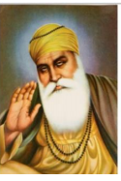 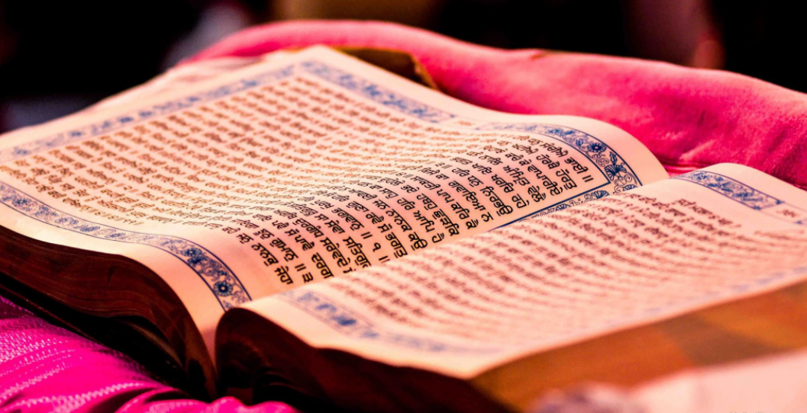

**What should we be able to do?**

*Understand that Guru means teacher and the purpose of a Guru to share the light of God.*

*Describe what a Sikh might learn from stories of Guru Nanak.*

*Understand the significance of Ik Onkar as representing the Sikh belief in one god.*

*Describe how and why Sikhs show the Granth the respect due to a living guru and how this is like or different from how other holy books are treated.*

*Understand how a Sikh will listen to the true Guru through chanting and meditating.*

**What should we know?**

A **Guru** is a teacher who gives guidance from God.

Sikhs believe:

* In one God ‘Waheguru,’ the most wonderful teacher.
* That no one religion is the only true way to Waheguru. We are all children of God.
* Guidance from God came to humans through ten Gurus.
* Guru Nanak was the first Guru. He wanted to teach people how they should live their lives and try to bring them into the light.
* The Guru Granth Sahib continues to lead those who choose to follow its teachings from Darkness to Light. Sikhs are encouraged to listen and meditate on its words.
* Repeating ‘Waheguru’ focuses the mind and helps you know God better.

Guru Nanak - *All that matters is to love God in your heart and to worship God with all your soul.*

**What words should we understand and be able to use?**

|  |  |  |  |
| --- | --- | --- | --- |
| **Sikhism** | Based on the belief in One God, the Sikh religion recognizes the equality of all human beings. Sikhism is more properly known as SIKHI; Sikhism is a western term. | **Guru Nanak** | The founder Guru of Sikhism regarded as the embodiment of Divine Light. |
| **Sikh** | Sikh (pronounced ‘seek’ in Britain but ‘sic’ is more accurate) means learner, disciple or follower of the Gurus. | **Guru Granth Sahib** | The final Sikh Guru in the form of a book of hymns and prayers written by the gurus. Given the same respect as a living human Guru. |
| **Guru** | For Sikhs this term means a teacher who gives guidance from God. The word Guru is composed of two terms: GU means darkness and RU- means Light. A guru is Human in form, divine (of God) in spirit. | **Waheguru** | God has many names in Sikhism and Waheguru is probably the most important and most common |