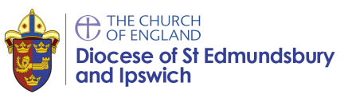
Photo permissions form for adults
For use by churches and associated organisations

Church name:_______________________________________________________________
Occasionally, we may take photographs of the people at our church. We may use these images in our printed publications that we produce, as well as on our website or on project display boards at our church. The diocese may also use our photographs to illustrate work in Suffolk churches in diocesan publications, publicity materials and the internet.
From time to time, our church may be visited by the media who will take photographs, film footage or carry out radio interviews. Images may appear in local or national newspapers, or on televised news programmes. Photos for the media and other publicity purposes may also be taken at events where our church is taking part.
Please answer the questions below, then sign and date the form where shown. Please return the completed form to the church as soon as possible.
- Are you happy for your photograph to be used in publications and publicity materials produced by the church and by the diocese?
YES  NO 
- Are you happy for your image to be used on our website and the diocesan website?
YES  NO 
- Are you happy for your image to be recorded on video or webcam?
YES  NO 
- Are you happy to appear in the media? This may mean your photo and name is used in print.
YES  NO 
Please note that websites can be viewed throughout the world and not just in the United Kingdom where UK law applies. Please also note that the conditions for use of these photographs are on the bottom of this form.
I have read and understood the conditions of use below.
Signature: Date:
Name (in block capitals):

Address (in block capitals):
Telephone number:

