DWELLING IN THE WORD

How we Dwell in the Word

- Listen to the passage read
- Consider where it ‘captures’ you, speaks to you and/or what question(s) it raises for you
- Walk across the room to find a person in the group you do not know or know less well, a ‘reasonably friendly-looking stranger’.
- Listen to that person as he or she tells you what they heard in the passage. They may mention something they’d never heard before, something odd or something comforting, or something about which they’d like to ask a Bible scholar. Then report what you heard.
- Listen well, because your job will be to report to a larger group of 4-6 what your partner has said, not what you yourself said. Some people take notes to help them focus and remember.

A prayer as we Dwell in the Word
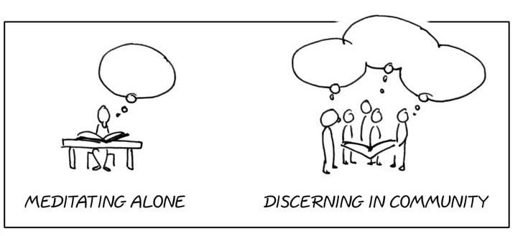
Loving God,
Though our destination is not yet clear,
May we trust in Your graceful promises;
Though we are uncertain of ourselves,
May we be rooted in Your loving regard;
Though our attention is inclined to wander,
May we hear the things You are saying;
Though we often neglect Your influence,
May we be convicted of Your power to change,
In Jesus Christ our Lord, Amen.

27 Only, live your life in a manner worthy of the gospel of Christ, so that, whether I come and see you or am absent and hear about you, I will know that you are standing firm in one spirit, striving side by side with one mind for the faith of the gospel, ⁵Let the same mind be in you that was in Christ Jesus, ⁶ who, though he was in the form of God, did not regard equality with God as something to be exploited, ⁷ but emptied himself, taking the form of a slave being born in human likeness. And being found in human form, ⁸ he humbled himself and became obedient to the point of death—even death on a cross. ⁹ Therefore God also highly exalted him and gave him the name that is above every name, ¹⁰ so that at the name of Jesus every knee should bend, in heaven and on earth and under the earth, ¹¹ and every tongue should confess that Jesus Christ is Lord, to the glory of God the Father.
Phil 1.27, 2.5-11

