Support Us – Please Donate
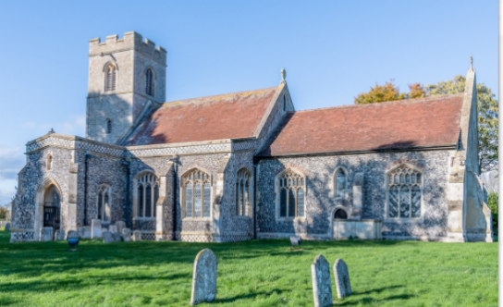
xxx church has been at the centre of xxx for over 1,000 years. For generations, it has been a place of worship, refuge, reflection and joy. Please help us to ensure it stands for another 1,000 years!
It costs £xxx per week to keep this beautiful and historic church open. Please support us by giving via the QR code above. Thank you!

