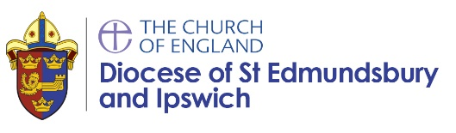
RE Pupil Voice

Can you show me a piece of work you really enjoyed in RE? Why did you enjoy it?
Is there something you really enjoyed in RE that you can’t show me e.g. drama, discussion, modelling? Tell me about it.
Can you show me a sample of work where you felt you learned lots? What did you learn?
What important things have you learnt about Christianity and other religions? Is your knowledge improving?
How do you know if you have done well in RE?
How do you know what your next steps are? Can you show me / tell me about some feedback that was helpful to you?

What type of activities do you enjoy best in RE? What would make RE even better?

How does RE help you as a learner and a person? Has anything you’ve learnt about inspired you?

Is RE important in a school? Why/why not?

Are people’s views listened to and respected in RE? Do discussions in RE ever refer to or remind you of your school’s Christian values?

