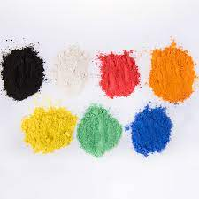
KS1 How does a Hindu celebration devotion to a deity at the festival of Holi?
Krishna
Holika and Prahlad
Shrine
Celebrating and throwing colour
What should we know?
Hindu’s believe:
- That Holi is a time to celebrate and show devotion to God.
- That stories teach what God is like.
- That stories are a big part of Holi.
- Throwing colours and playing pranks at Holi is a way of remembering Krishna.
- Many Hindus show devotion to God at a shrine in their home.

Throwi
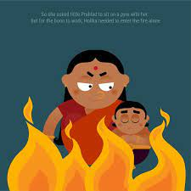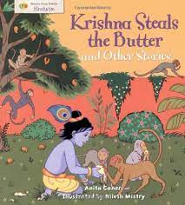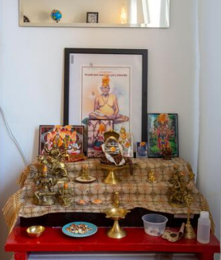

What should we be able to do?
Recognise pictures of Holi being celebrated in different ways.
Recall some of the details of the Prahlad and Holika story.
Know Krishna liked to play tricks.
Describe a Hindu shrine.

What words should we understand and be able to use?
Holi | A Hindu festival which celebrates spring, love and new life. | Vishnu | Vishnu is a very important Hindu God. The preserver and protector of the universe.
Krishna | A popular Hindu deity. | Radha | A milkmaid who Krishna was devoted to.
Shrine | A shrine contains important objects that are used for worship. | Deity | Another word for ‘God.’ The Hindu deities are the Gods and Goddesses in Hinduism.

