EYFS What makes every single person unique and precious?
What should we know?

Christians believe:
- We are all precious and unique.
- God cares about us and what happens to us.
- Jesus welcomed everyone because we are all precious.
- Saying thank you to God is important.
- Jesus taught - do for others what you want them to do for you. This means we should help others.

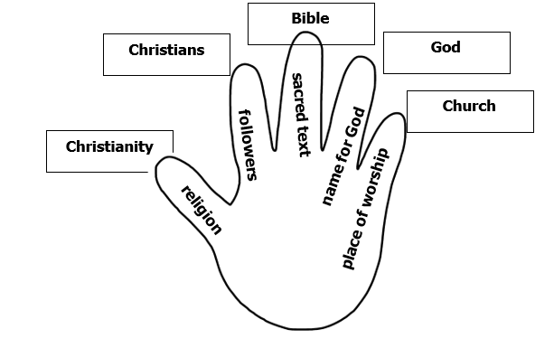
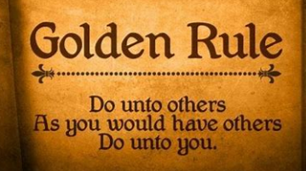
What should we be able to do?
Listen to a Christian welcoming song.

Recognise why a ‘thank you’ song to God is important to a Christian.

Recognise something a Christian might do to follow the Golden Rule which Jesus taught them.
Vocabulary
God | Christian | Thankful
Jesus | precious | vicar
Bible | unique
church | Golden Rule

