UKS2 How do the ‘Heroes of Faith’ encourage Christians today?
What should we know?
Christians believe God can be trusted. We can put our faith in him and his promises.
Christians believe:
- The Bible contains stories of heroes who showed faith in God and his promises.
- It was by faith that David killed Goliath.
- Growing in ‘faith’ means learning to trust God.
- Christians go to church to worship God and learn together more about their faith so it grows and develops.
- Jesus said faith is like a mustard seed. It starts small but can grow big.

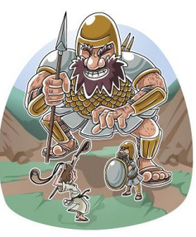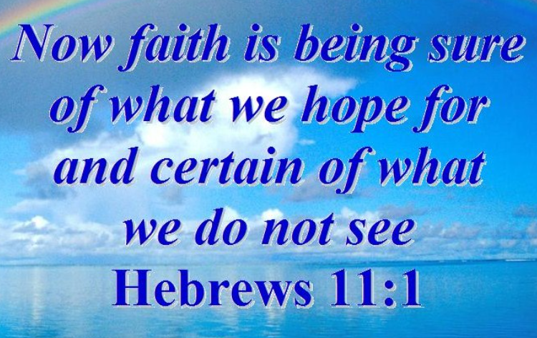
A Christian’s faith makes a genuine difference to how they live their lives. They grow their faith by using the example of Heroes of Faith found in the Bible.
What should we be able to do?
Recall stories about heroes of faith from the Bible.
Describe Christian teaching about faith.
Make links that show how Christians believe that hearing about ‘heroes of faith’ from the Bible, or people’s lives gives them courage and strength.
In KS1: Christians are followers of Jesus, the saviour of the world. He died at Easter but came back to life.
Jesus told parables to teach about God.
Christians pray to God and worship him in different ways.
The Holy Spirit reminds Christians God is always with them.

T
Thgehe

What words should we understand and be able to use?

