UKS2 When Christians need real wisdom where do they look for it?
What should we know?
Christians believe that true wisdom comes from God and that, as they grow in faith, so their wisdom will also grow.
Christians believe:
- Proverbs pass on wisdom from people who have faced similar dilemmas and choices to us.
- The Book of Proverbs in the Bible was written by King Solomon and is a source of wisdom for Christians.
- When praying, Christians ask God for wisdom – to know what to do or how to help.
- God’s wisdom is reflected in the beauty of creation.
- The Psalms teach that the human skills of creation are also seen as wise because these skills come from God.
- Jesus taught a wise person trusts in God.
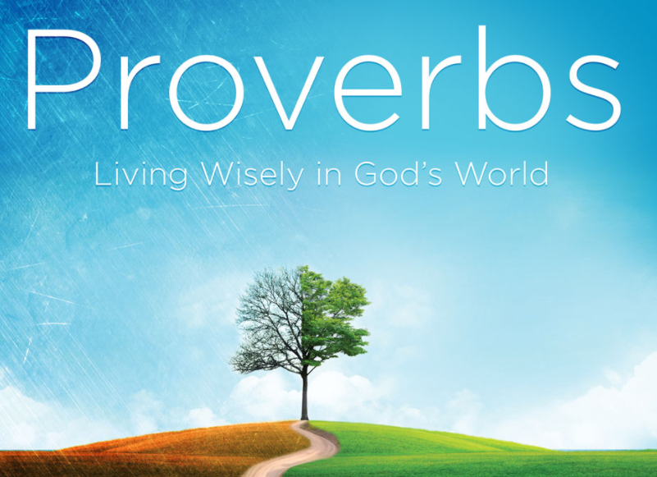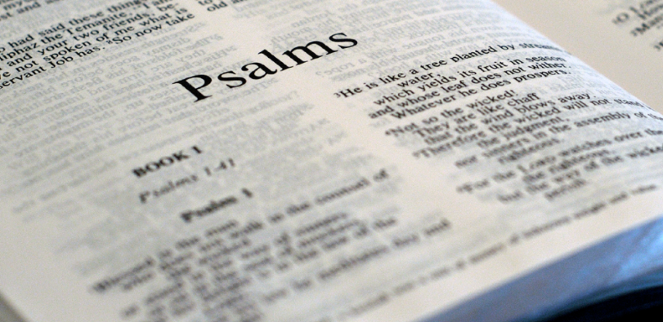
Christians believe true wisdom comes from God. They use the Bible as a source of Wisdom.
What should we be able to do?
Recall the story of Solomon’s wise choice.
Remember some facts about Proverbs and Psalms.
Explain that Christian ideas about wisdom come from the Book of Proverbs, or other Wisdom teachings, in the Bible.
Recall some of Jesus’ teachings about wisdom and foolishness.
In KS1: Christians are followers of Jesus, the saviour of the world. He died at Easter but came back to life.
Jesus told parables to teach about God.
Christians pray to God and worship him in different ways.
The Holy Spirit reminds Christians God is always with them.

T
Thgehe

What words should we understand and be able to use?
Proverbs | The Book of Proverbs in the Bible contains practical advice for living God’s way. | Psalms | The hymn and prayer book of the Bible.
Sermon on the Mount | A collection of sayings and teachings by Jesus. | Foolishness | The wrong understanding of life.

