**KS1 What are the best symbols of Jesus’ death and resurrection at Easter?**

**Prior learning:**

Jesus is the saviour of the world. He told parables to teach about God.

Everyone is welcome into the Christian family.

Christians pray to God and worship him in different ways.

The Holy Spirit reminds Christians God is always with them.

**What should we be able to do?**

*Remember one of the Easter stories.*

*Describe different symbols used at Easter.*

 

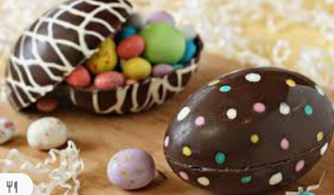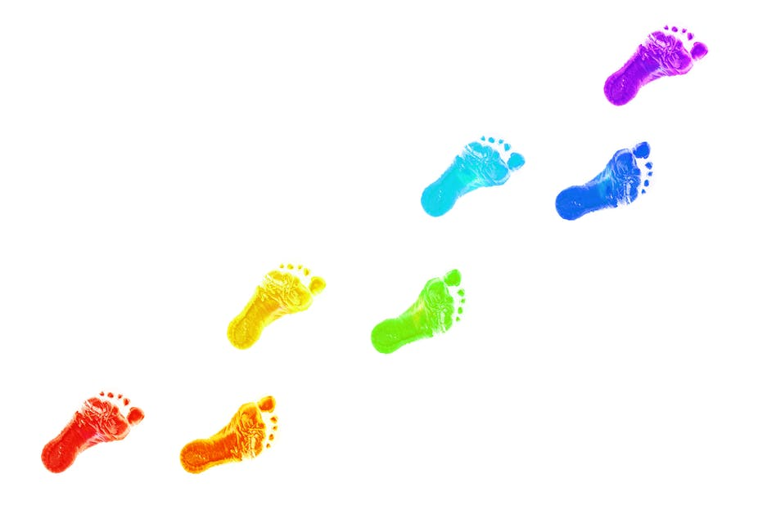

**What should we know?**

Christians believe:

* Jesus died at Easter but came back to life.
* Jesus is alive in heaven.
* Easter is a time of celebration.
* There are different symbols used in the Christian tradition.

The cross symbolises the whole Christian faith.

**T**

**Thgehe**

**What words should we understand and be able to use?**

|  |  |  |  |
| --- | --- | --- | --- |
|  |  |  |  |