KS1 How do some Muslims show Allah is compassionate and merciful?
Muslim stories about compassion.
Following the straight path.
Ramadan a month of fasting.
What should we know?
That Muslims believe in Allah – the one true God.
Muslims believe:
- That Allah is a compassionate God.
- That if Allah is compassionate, Muslims should be too.
- Allah wants Muslims to look after all living creatures.
- That Muhammad is an example for all Muslims to follow.
- That being hungry helps them feel compassion for those in need.
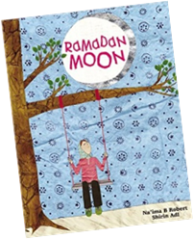
What should we be able to do?
Recognise that the names ‘Allah’ and ‘Muhammad’ are important to Muslims.
Tell a story about Muhammad and an animal and say that it teaches a Muslim about compassion.
Recall some of the different names of Allah e.g. the doer of good, the generous.
Talk about what Muslims do during Ramadan. Use the words ‘fasting’ and ‘sharing.’
Talk about how some Muslims show compassion at Eid with examples like giving gifts to those in need.

What words should we understand and be able to use?
Qur’an | A Muslim’s special holy book. Always treated with respect and never put on the floor. | Arabic | The language of the Qur’an and the language spoken in the Middle East.
Muhammad | Allah’s last prophet (his messenger). He is very special to all Muslims. | Compassionate | Feeling and showing concern for others.
Allah | The Arabic word for God. | Islam | The religion Muslims follow.

