[insert name] Deanery
Mission and Pastoral Planning

Deanery Planning Template

Owner/Contact:

Date last reviewed:

“I planted, Apollos watered, but God gave the growth" (1 Corinthians 3:6)
[Last revised - December 2018]

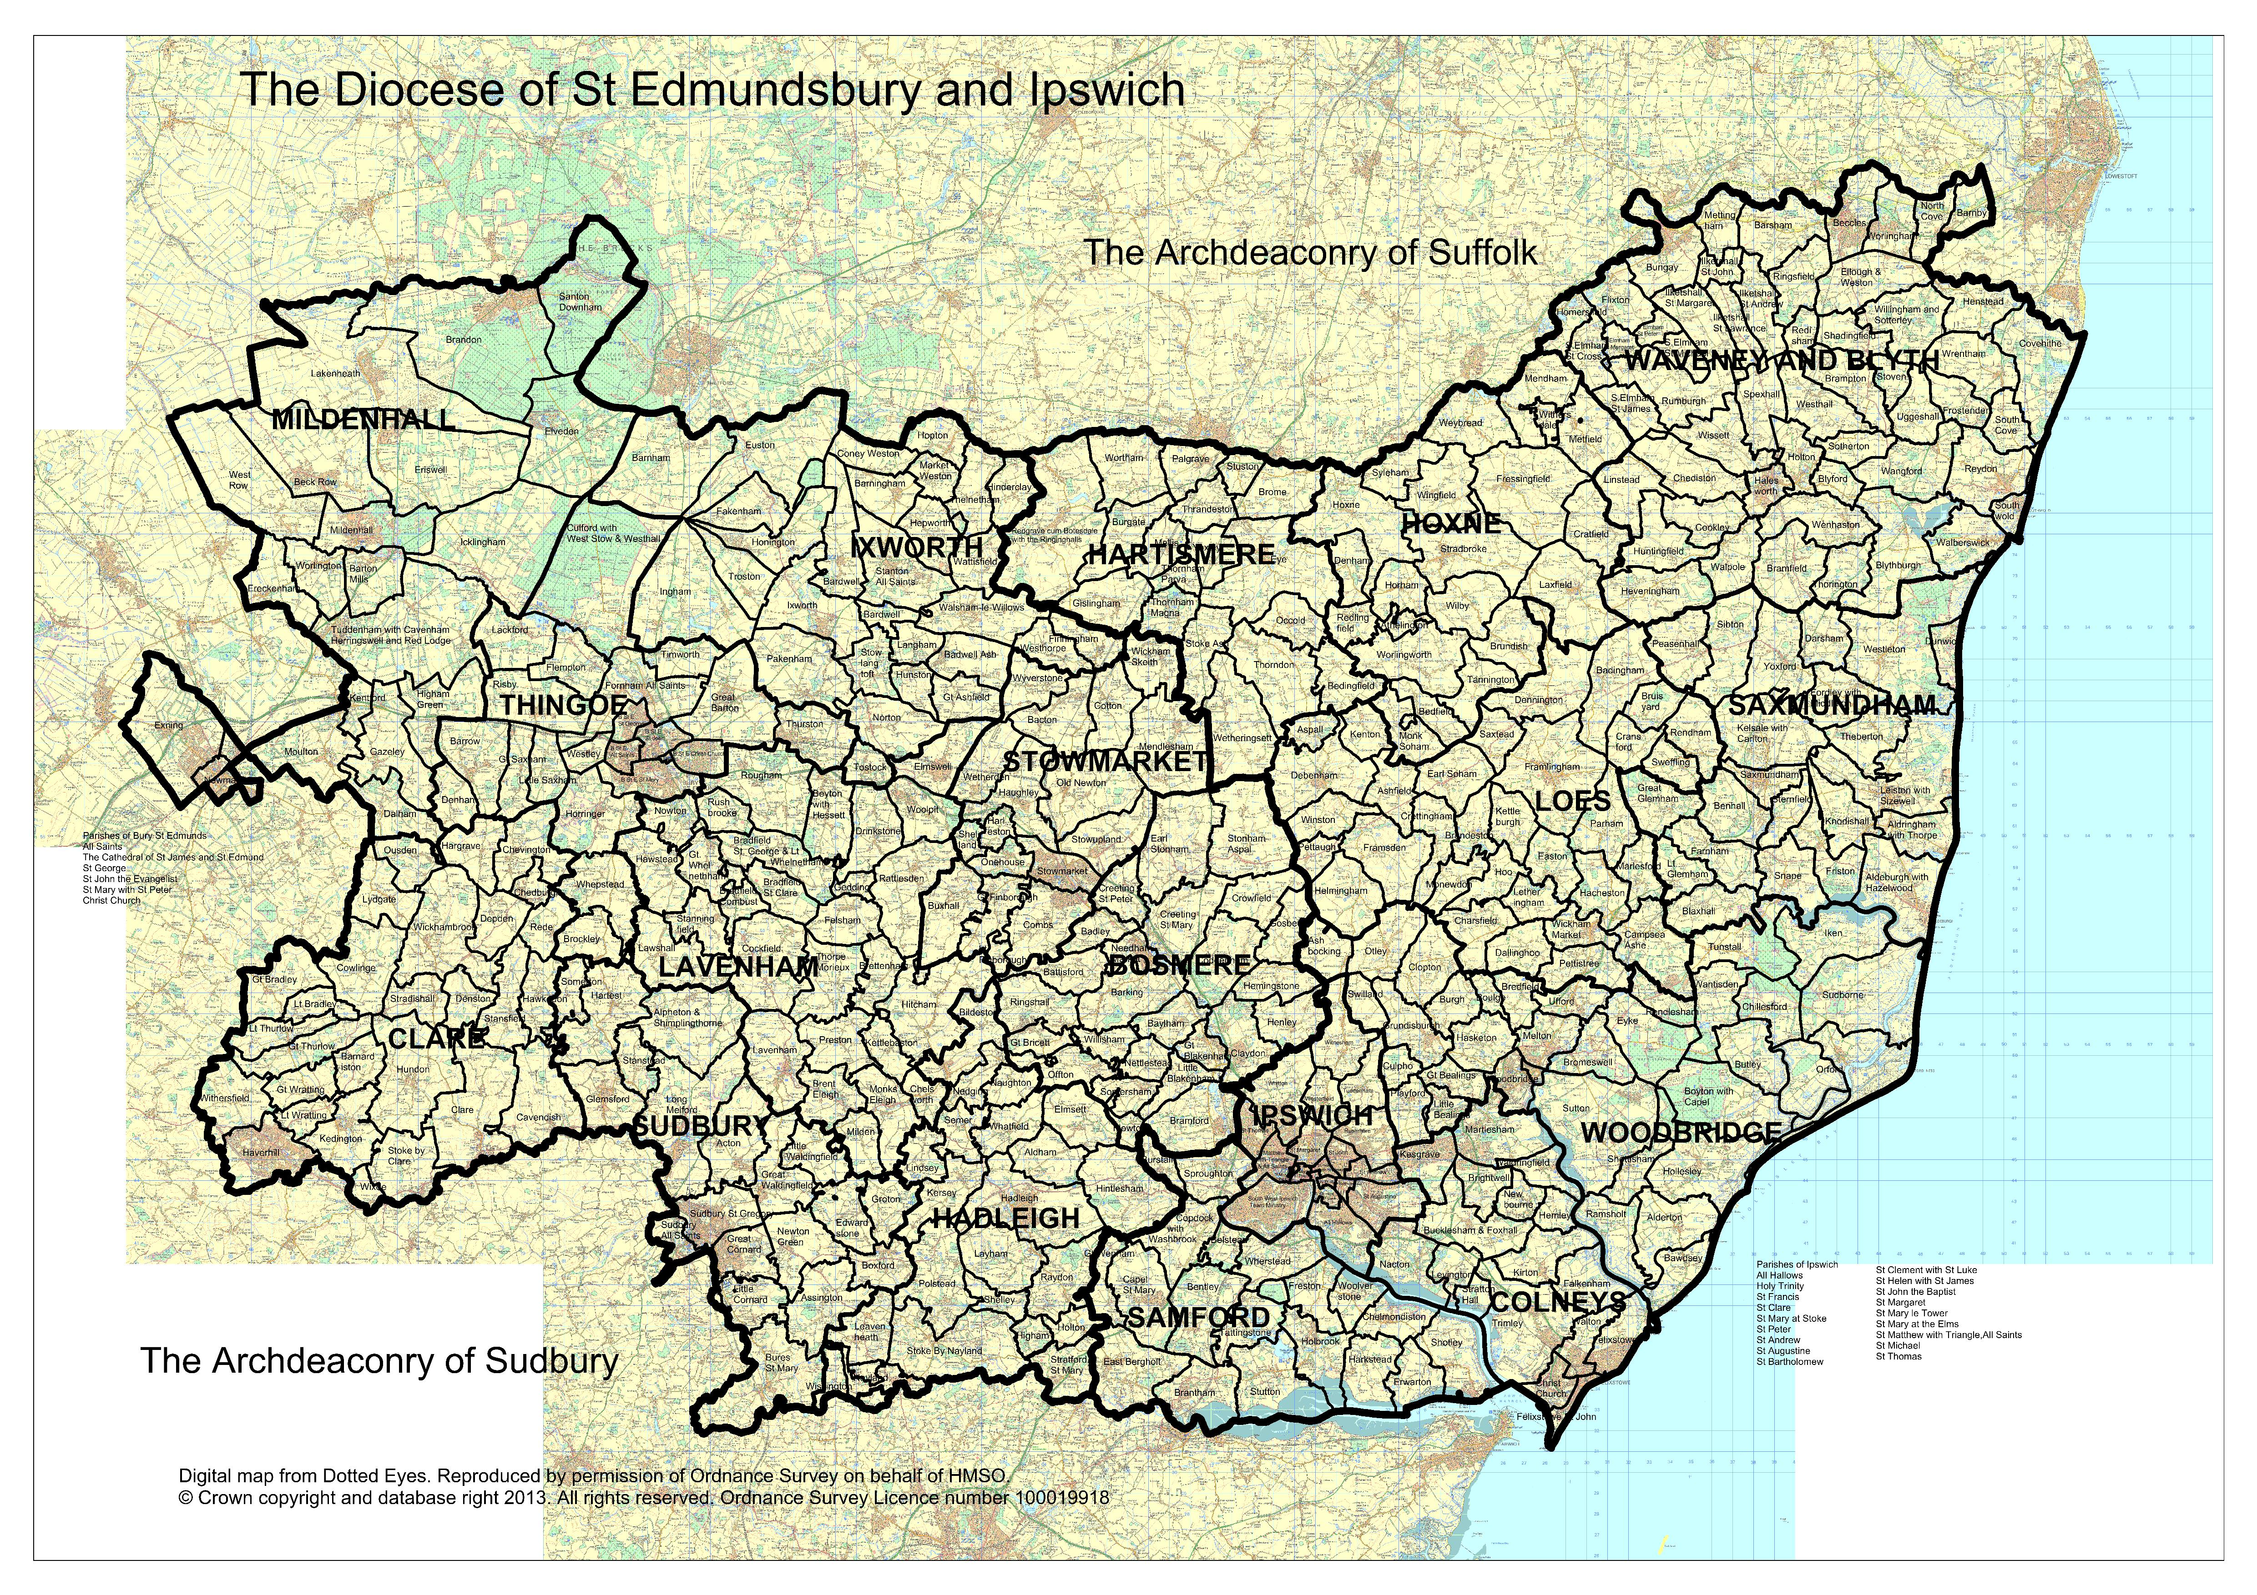

Deanery Audit

Benefice planning audits should be compiled into this deanery document:

Existing Resources

Physical

ITEM | NUMBER and/or NAME(S)
Parishes
Parishes included above that are in the top 20% for deprivation
Ecclesiastical buildings
Other buildings (e.g. parish halls, church rooms, youth centres)
Church schools
Other schools

Colleges and university campuses
Hospitals and care homes
Average Weekly Attendance
Average weekly planned giving
Gift Aid claimed as % on annual, regular offerings
Parish Giving Scheme
- Number of parishes that are members?
- Number of parishioners that are donors?

People

The same person may appear in more than one category, please count them each time.

Stipendiary clergy – number of ‘established’ posts
Self-supporting clergy
Clergy with PTO
Pioneer ministers (no. of Lay /Ordained– including those counted above)
Readers
Chaplains (both Anglican and ecumenical appointments)
Ministers in Secular Employment
Lay Elders
Other accredited lay ministers
Healing prayer ministry
Spiritual accompaniers
Youth workers⁷
People in house Bible groups
People in house Prayer groups
Local Giving Advisers
Churchwardens
Deputy/Alternate Churchwardens
Number of parishes with administrators
PCC Secretaries
PCC Treasurers
Electoral Roll number
Population
Others (please list)
Other denominations within the parish (list)

Learning from our Statistics

What key strengths do we have? | 1.  2.  3.

What needs do we have?

What opportunities are there? *

What do the statistics show?

*Possible Considerations

- Boundary Changes (internal or external)
- New Housing
- Schools

Fabric and Forward Planning

Fabric and Forward Planning* | Enabler  Parish / person

*Possible considerations:

- Impending Vacancies
- Pastoral reorganisation
- New [church] buildings (Capital projects for mission-focussed church improvements)
- National projects and campaigns (e.g. Thy Kingdom Come)
- Working with and across denominations and faiths

Growing in God
Our Vision: Growing in God: "Flourishing Congregations Making a Difference"
Our Mission: To grow in depth and influence, so as to increase in number and be younger

Diocesan Measures

GIG  Priority | Objective | Measure | Source | Baseline & Targets
 |  |  |  | 2017 |  | 2020 | 2024
Depth | Increase the number of authorized and commissioned lay ministers | Total Ministers | Readers | 163 |  | 195 | 195
 |  |  | Elders | 509 |  | 528 | 528
 |  |  | Pioneer | 0 |  | 10 | 20
 |  |  | Missional Group Leader | 0 |  | 2 | 10
 |  |  | Evangelist | 3 |  | 6 | 18
 |  |  | Youth | 0 |  | 6 | 18
 |  |  | Children/Family | 0 |  | 1 | 3
 |  |  | Total | 675 |  | 764 | 792
 | Increase in average weekly planned giving (to national average level) | Average Weekly Planned Giving | Parish Finance Returns/National Stewardship | £9.64  (£11.87) |  | £11.43 | £14.42
Influence | Increase the total number of community projects by at least 20. (focussed on those in greatest need) 1 per deanery, 1 x diocese, 1 x Kagera (partner diocese in Tanzania) | Community Impact Assessments | Community Affairs Survey | X |  | X+8 | X+20
Number | Halt the decline in church attendance | Average Weekly Attendance | Statistics for mission | 13600 |  | 14500 | 15000
 | Halt the decline in Electoral Rolls | Electoral Roll Numbers | Statutory Parish Return | 19000 |  | 19000 | 20000
 | Create new Fresh Expressions of Church | Number of new Fresh Expressions | Statistics for mission | 5 |  | 15 | 30
Younger | Decrease in average age of a worshipping community (relative to local demographic) | Worshipping Community Data | Statistics for Mission/  Suffolk | 0-17 | 14% | 17% | 20%
 |  |  |  | 18-69 | 44% | 46% | 50%
 |  |  |  | 70+ | 42% | 37% | 30%
 | Create projects that develop partnerships between churches and schools that enable an encounter with the Christian faith | Number of projects | Diocesan Board of Education | 0 |  | 1 | 5

Growing in Depth

Consider:
- Baptisms, Confirmations and extra-parochial teaching events
- Daily prayer; Bible study, Quiet Days, Retreats – using Diocesan Spirituality Group, Pilgrimages
- Developing discipleship amongst the Laity (Setting God’s People Free)
- Increase numbers of planned givers (plus 5%), and their level of giving
- Increase Ordinands (plus 50% across the Diocese) and Pioneers and Evangelists (20 of each across the diocese)
- Other:

What we do now:
Plans for the future, with timescale:
Extra resources needed and cost:

Growing in Influence

Consider:
- Community Projects
- Support Church and Community schools
- Challenge injustice and promote The Common Good working with diocesan campaigns and groups such as Christian Aid, Christians Against Poverty, etc.
- New partnerships with chaplains in schools, hospitals and uniformed groups
- Promoting inclusion and access for those with visible and hidden disabilities
- Other:

What we do now:
Plans for the future, with timescale:
Extra resources needed and cost:
Growing in Number

Consider:
- Reverse fall in attendance
- Reverse fall in electoral roll
- Fresh Expressions of church
- Christian communities and new housing
- Occasional Offices: Weddings and Funerals – use resources from Church of England Life Events website www.churchsupporthub.org
- Other:

What we do now:
Plans for the future, with timescale:
Extra resources needed and cost:
Growing Younger

Consider:
- Decrease in congregations’ average age
- Increase in ‘Under 18s’
- Church / School partnerships
- Commission children’s and youth workers
- Other:

What we do now:
Plans for the future, with timescale:
Extra resources needed and cost:

Summary Deanery Planning

Please identify a maximum three priorities for each missional objective, proposed plans and timescales, what additional resources and any expected costs and who could be the primary enabler.

Priority | Plans to achieve | Timescale | Resources/Costs | Primary Enabler
Growing in Depth
(1)
(2)
(3)
Growing in Influence
(1)
(2)
(3)
Growing in Number
(1)
(2)
(3)
Growing Younger
(1)
(2)
(3)

Thank you for completing your Deanery Planning. Please return to your Archdeacon.

Refer to calculation of IMD on Parish dashboard – list all below 20%
Include non-consecrated chapels etc.
Include only buildings that a parish maintains and or manages.
Schools & Colleges: Please name each establishment. This will provide data to resolve any confusion when consolidating information.
Regular, annual offerings: the aggregate annual value of collections in the plate, free will offering envelopes, standing orders paid directly to parish’s bank account, and regular donations via Charities Aid, Stewardship or the like. Exclude occasional donations, proceeds of church fetes or specific fundraising events.
The number used to calculate parish share regardless of any vacancies.
Include those working across more than one parish or ecumenically
An ordained person in employment without parochial responsibility.

