KS1 Why is learning to do good deeds so important to Jewish people?
Zoe and her family are Jewish.
What should we know?
Mitzvah is the Jewish word for good deed or action. It is something God asks all Jews to do.
Jews believe it’s a mitzvah (good deed) to:
- HELP others in need.
- WELCOME others.
- GIVE money to help other people
- CARE for the world.
Mitzvahs make a Jewish person feel like they belong.
What should we be able to do?
Describe Zoe as being a Jew.
Remember something about the story of Ruth.
Describe how Jewish people welcome babies into their community.
Give an example of how a Jewish people might care for their world.

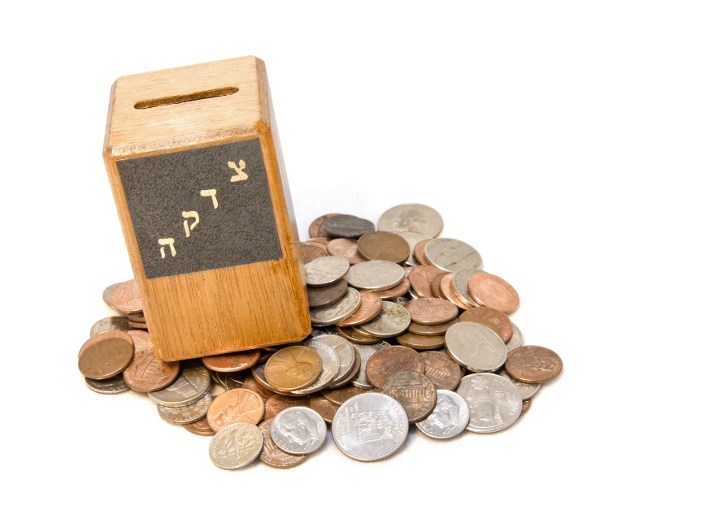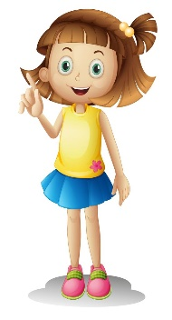
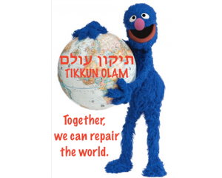
What words should we understand and be able to use?
Jewish | Some families are Jewish. Jewish people believe in God and follow a book called the Torah. | Tikkun Olam | Healing the world.
Mitzvah | The Jewish word for a good deed. | Tzedakah box | For giving money to help other people.
