UKS2 How do Christians try to capture the mystery of God as Trinity?
What should we know?
Christians struggle to express the idea of the Trinity. It is a mystery.
Christians believe:
- Christians believe in one God but they experience Him in three ways (Father, Son, Holy Spirit).
- When Jesus was baptised all three persons of the Trinity were present.
- When Jesus left earth, he asked his followers to baptise new Christians ‘in the name of the Father, the Son and the Holy Spirit.’
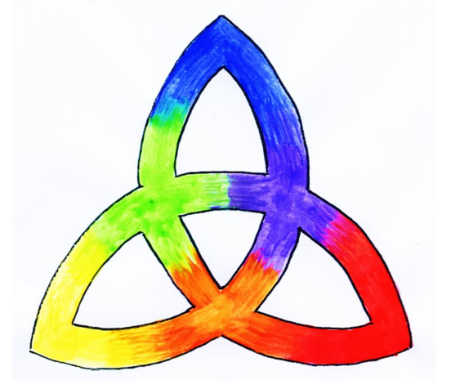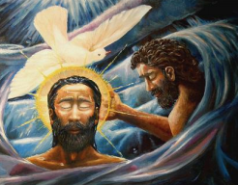
The Grace of our Lord Jesus Christ and the love of God and the fellowship of the Holy Spirit be with us all evermore.

+
Christians experience God as the Holy Trinity, as three separate persons.
What should we be able to do?
Explain some of the reasons why Christians believe God is Trinity and explain how this is based on the way they experience God as well as hinted at in Biblical text.
Describe and compare ‘Trinitarian’ practices.
In KS1: Christians are followers of Jesus, the saviour of the world. He died at Easter but came back to life.
Jesus told parables to teach about God.
Christians pray to God and worship him in different ways.
The Holy Spirit reminds Christians God is always with them.

T
Thgehe

What words should we understand and be able to use?
Mystery | A mystery is something that is difficult or impossible to understand or explain. | Atheist | The belief that there is no God.
Agnostic | One who is not sure or who thinks it is not possible to prove there is  a God. | Trinity | tri-unity or three in one.
Icon | An icon is an image created for worship.

