LKS2 How do Christians show that ‘reconciliation’ with God and other people is important?

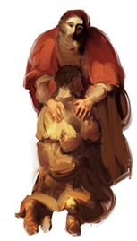

In KS1:
Christians are followers of Jesus, the saviour of the world. He died at Easter but came back to life.
Jesus told parables to teach about God.
Christians pray to God and worship him in different ways.
The Holy Spirit reminds Christians God is always with them.

What should we know?
That reconciliation is about fixing what is broken.
That Christians believe:
- The world needs reconciliation.
- The Bible and stories Jesus told teach about reconciliation.
- God offers forgiveness to all who repent and admit wrongdoing.
- Asking God for forgiveness is called confession.
- That God wants us all to be peacemakers.

What should we be able to do?
Explain that reconciliation means mending a broken relationship.
Understand that Christians learn about reconciliation from the Bible through stories Jesus told such as the prodigal son.
Explain that Christians believe God wants them to be peacemakers based on the example of Jesus.

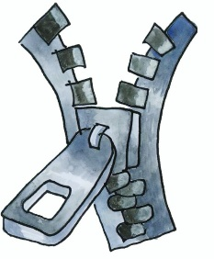
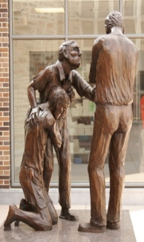

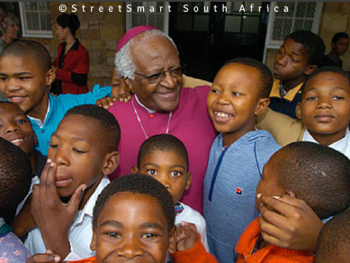

T
Thgehe

What words should we understand and be able to use?
Parable | Stories Jesus told to help his followers learn more about God; they are like mystery stories with lots of special meanings in them. | Reconciliation | Reconciliation is the technical word for mending friendships. It can be the mending of a broken friendship with God or with others.

